Author Guidelines for the *tec2zero conference*  
[Title: two lines, 170 characters maximum]

Max Mustermann1 [main author] | Paul Smith [co-author] | Madison Paul2 [2st co-author] | and so on…

**Correspondence**

Dr. Paul Smith

University of Wuppertal

Institute for Net Zero Studies

Gaußstreet 500

42119 Wuppertal  
Email: [p.smith@uni-wuppertal.de](mailto:p.smith@uni-wuppertal.de)

1 Affiliation, Town, YYY

2 Affiliation, Town, YYY

**Abstract**

[Abstract: 1400 characters maximum] The University of Wuppertal is continuously developing its profile in research and teaching. This brings together existing strengths, releases new synergies and strengthens the visibility of our potential and achievements. The clear profile architecture supports the implementation of our principles: The University of Wuppertal focuses on positive distinctiveness, for increased regional, national and international attractiveness and charisma.It mobilises the potential of its members with a view to a clear resource orientation in the pursuit of common goals. The tried and tested and the new are wisely weighed against each other in the sense of a balance between stability and flexibility, in order to make use of innovations without rashly abandoning the established. Action at University of Wuppertal has a clear value reference: understanding society, culture, technology and nature as well as their change must go hand in hand with the endeavour to also help shape them and thus create a democratic, open and pluralistic society for future generations as well. All content-related decisions at the University of Wuppertal are made within the profile lines that have been anchored in our mission statement since 2009 as strategic, interdisciplinary focal points.

**Keywords**

Article, Activity Field, Technology, Zero-Waste, zero-Carbon [up to 8 keywords]

# Introduction

The University of Wuppertal is continuously developing its profile in research and teaching. This brings together existing strengths, releases new synergies and strengthens the visibility of our potential and achievements.:

* Articles have to be written by the authors themselves. They must be the copyright holder of all material submitted (such as photos, pictures, drawings). Fees requested subsequently by third parties must be paid by the author.
* Beispieltext, Beispieltext, Beispieltext, Beispieltext, Beispieltext, Beispieltext, Beispieltext, Beispieltext, Beispieltext, Beispieltext, Beispieltext, Beispieltext, Beispieltext, Beispieltext, Beispieltext, Beispieltext, Beispieltext, Beispieltext, Beispieltext, Beispieltext.

Beispieltext, Beispieltext, Beispieltext, Beispieltext, Beispieltext, Beispieltext, Beispieltext, Beispieltext, Beispieltext, Beispieltext, Beispieltext, Beispieltext, Beispieltext, Beispieltext, Beispieltext, Beispieltext, Beispieltext, Beispieltext, Beispieltext, Beispieltext, Beispieltext, Beispieltext, Beispieltext, Beispieltext, Beispieltext.

# Structure and design

## Formal structure

The text length of an article/essay should not exceed 40.000 characters (including spaces) and respectively maximum eight printed pages of A4 format including figures, tables and references. , and it should be written in Word Verdana font 8,5 point font size and 1,1 line spacing. Please do not make any changes to the paragraph format settings.

The title should be short and to the point. The first and family names of all the authors are to be listed without academic degrees on the top of the first page.

Authors should use clear, straightforward language. The manuscript must be ready for printing. The text should be clearly structured by subheadings and numbered using the decimal system. Every article starts with ‘1’ and ends with ‘References’.

We ask the authors to provide a corresponding author with the complete name, including academic title and postal address (preferably the company or institution).

Authors are asked not to use footnotes within the text. If unavoidable, they should contain only factual information and no references. Footnotes should be numbered consecutively.

## Figures and tables­

Images and tables are numbered consecutively with Arabic numerals. Each image and table is to be mentioned at least once in the text. They should be placed in the body of the text at the end of the section where they are first mentioned.

If images consist of individual subfigures, where possible these should be recorded as single images and the figure numbers allocated lower case Arabic letters (e.g. a–f). Where possible as regards length, captions for subfigures should be summarised in one caption.

Table 1 Description of the different types of buildings

|  |  |  |
| --- | --- | --- |
| Variant | building | Number of rooms |
| 0 | Residential | One |
| 1 | Office | Two |
| 2 | Residential | Three |
| 3 | Office | four |

Size of the illustrations is based on the printable space:

* minimal width = 87 mm (single-column)
* maximal width = 180 mm (two columns)
* maximal height = 260 mm (full page, portrait format)

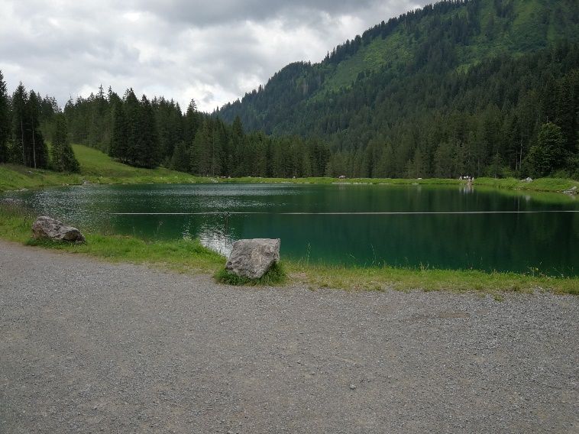

Figure 1 Photos are to be provided in JPG, PNG, BMP format. Minimum resolution of 150dpi required. Source: Photographer/Institution

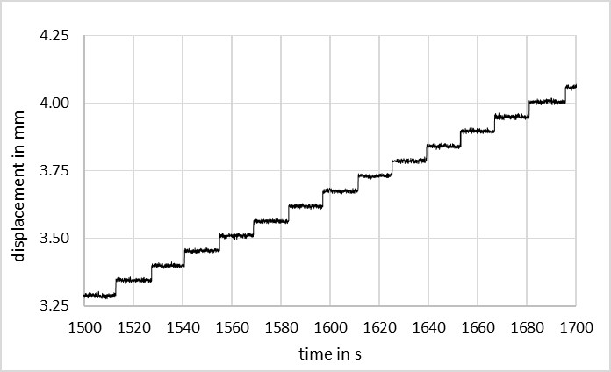

Figure 2 Subfigures are to be numbered a), b), c) ... etc. Source must be given.

Table 2 Preferred image formats and resolutions

|  |  |  |  |
| --- | --- | --- | --- |
| **Type of image** | **Graphics format** | **Resolution** | **Width for single-column setting** |
| **Technical drawings** | PNG (24 bit), TIFF | 300 dpi | 1024 px  (min. 720 px) |
| **Line drawings** | Colour: PNG (24 bit), TIFF  B/W: TIFF | 300 dpi  800 dpi | 1024 px (min. 720 px)  2770 px (min. 1600 px) |
| **Photos** | JPG, (TIFF) | 300 dpi | 1024 px (min. 720 px) |

## Symbols and formulas

Formulas and other symbols must be the same in texts, illustrations and tables. Indices and exponents should be clearly subscripted or superscripted. Please take care not to mix Greek, Roman, Latin and Arabic symbols when typing in upper- or lower-case letters – e.g. γ (gamma), y and Y, o, O and 0 (zero), ω (omega), w und W, Arabic ‘1’ and the lower-case ‘l’ as in ‘letter’.

## Equations

Equations should be typed using MS Word Equations Editor or MathType. Equations (1) should be numbered consecutively:

$e=m∙c^{2}$ (1)

# Uploading your contribution

The document has to be submitted as a Word document and be named according to the following scheme:

contribution number_first-author.docx

The document has to be submitted as a Word document and be named according to the following scheme:  
*contribution number_first-author.docx*

To upload your paper, go to the conference website, select your contribution and upload it clicking on “Präsentationsmaterialien”, as given in Figure 2:

<https://indico.uni-wuppertal.de/event/413/>

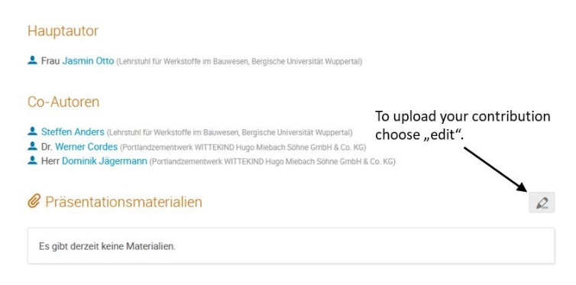

Figure 2 Screenshot of the indico-homepage to upload your contribution by choosing “edit” in the lower part of the page

In case of questions please contact the conference secretary ([tec2zero@uni-wuppertal.de](mailto:tec2zero@uni-wuppertal.de)) for assistance.

References

References and quotations are listed at the end of the paper. References should be numbered using Arabic numerals, the number of the reference appearing in the text in square brackets, *in the order in which they appear within the text (not sorted alphabetically)*. The references should be quoted using abbreviated versions according to ISO 690. Within this document the format template *List: Literature* is available to format references. In the following, some citation examples of monographs and journal articles.

1. Zement, P.; Zuschlag, P. (2000) *Betontechnologie-Handbuch*. Wuppertal, Publisher Verlag.
2. Haenel, J.; Kina, J.; Schaumann, P. (1994) *Zur Erweiterung des Anwendungsbereiches von Stahlträgerverbundkonstruktionen*. Stahlbau **63**, H. 4, pp. 279–283.