Curative Congestion Management Service Models for Examination of their Signal Transmission Reliability

Bartosz Musiol1 | Christian Thöne2 | Markus Zdrallek1

**Correspondence**

Bartosz Musiol

University of Wuppertal

Institute of Power Systems Engineering

Rainer-Gruenter-Str. 21

42119 Wuppertal  
Email: [musiol@uni-wuppertal.de](mailto:musiol@uni-wuppertal.de)

1 Institute of Power Systems Engineering, University of Wuppertal, Wuppertal, Germany

2 Asset Management, Telecommunications & Op Control Centers, Network Management, Amprion GmbH, Dortmund, Germany

**Abstract**

Curative congestion management enables transmission system operators to resolve congestion scenarios after they occur, relying on timely and reliable communication between sensors, actors and grid control centers. This makes it more energy efficient than preventive congestion management, because redispatch can be avoided until a congestion actually occurs. This contribution analyzes signal transmission reliability within four communication service model variants, derived in earlier work from the InnoSys 2030 system operation process. The previously defined single pass model for special protection schemes is extended into three not yet defined models by introducing sequences of actor groups, and structured control center roles related to actors, sensors and the main grid control center. Assuming a communication network, reliability block diagrams are derived compatible with Markov models. A fictional yet representative network is employed as a proof of concept, illustrating how the different communication models influence system reliability. This structured approach is adaptable to transmission system operator specific architectures and supports automated reliability analysis, aiding the design of future-proof curative congestion management implementations.

**Keywords**

Curative Congestion Management, Reliability Block Diagram, Communication Network, Transmission Grid, Grid Control Center, Communication Routes, Communication Service

# Introduction

Curative congestion management (CCM) is a strategy for electrical transmission system operators (TSOs) to resolve congestion scenarios after they occur [1, 2]. This contrasts with preventive congestion management, which aims to avoid such scenarios in the first place at the cost of reacting to a congestion that does not occur, requiring redispatch, i.e., a change of otherwise optimized generation schedule in electrical power plants. CCM has been extensively evaluated within the InnoSys 2030 research project, particularly from a technical perspective [3].

CCM requires the exchange of signals between sensors, actors, and grid control centers (GCCs) [4]. This exchange constitutes a service. These signals are typically transmitted via a TSO’s communication network [5]. Generally, optical ground wires (OPGWs) connect wide area network routers in substations along power lines [5]. Recently, concepts involving the use of conventional routing protocols, such as Open Shortest Path First (OSPF), have been explored, with modifications to their cost metrics to suit TSO applications [6].

The exchange of signals is expected to follow a defined framework [4] for which various communication models can be developed. The framework in [4] supports reliability analysis (see [7, 8]), which requires sufficiently detailed descriptions of the communication processes, i.e., the CCM service. A structured approach for defining such models based on the InnoSys 2030 System Operation Process [9] is presented in [10]. There, four models are identified and categorized according to two binary parameters.

The first parameter considers whether redundant measures are present in the examined CCM, distinguishing between single-pass models (SPM) and multi-pass models (MPM). The second parameter considers whether the GCCs are involved in the initial response before any backup measures are applied (or, in the case of the SPM, before system failure). This parameter defines the Special Protection Scheme (SPS) and centralized (C) variants. The use of SPS in CCM has been examined in [11] and [12].

In summary, four variants have been identified: SPM‑SPS, SPM‑C, MPM‑SPS, and MPM‑C. While the SPM‑SPS model can be analyzed in detail with minimal involvement of a GCC—allowing for simpler operational assumptions [10], —the remaining three models require a more in-depth analysis of the GCC’s role in CCM.

In this contribution, Chapter 2 examines the role of GCCs in CCM and uses the insights gained to define the remaining three models. Chapter 3 uses these communication models to derive general forms of reliability block diagrams (RBDs), suitable for algorithmic use. Chapter 4 applies the models to a synthetic communication network along an electrical transmission grid as a proof of concept, providing example results. Finally, Chapter 5 presents the conclusions.

# Defining Communication Models

SPM‑SPS relies on only a few assumptions. Sensors (e.g., line protection) notify a predefined set of actors (e.g., HVDC converters) directly to set an operating point. GCCs receive only the success status signal from the actors, and do not contribute to the critical part of the communication during the congested state of the electrical transmission grid. This situation allows the model to simply assume that actors transmit their information straight to the responsible GCC for the present CCM measure (CCMM) without intermediate participants. [10]

In reality, TSOs have different hierarchies and structures for their GCCs. Some TSOs divide the responsibility for interacting with actors geographically, e.g., with different GCCs for the northern and southern areas. Another structure found in practice is that actors and sensors are operated by different GCCs. Even this division is not as clear-cut as a simple model would prefer to represent [13]

To model communication scenarios where GCCs are heavily involved, the concept of GCC roles is introduced. The presented communication models can only describe GCC roles, of which there are typically many more than there are physical GCCs. After assembling the RBDs (see Chapter 3), roles are mapped to physical GCCs. This means that even if a model includes dozens of GCC roles, the final RBD derived from the communication model may feature only one or two actual GCCs. Additionally, communications abstractly described between a GCC and itself are generally not meaningful and are typically omitted during mapping.

This does not affect the definitions for the SPM‑SPS, because in that case the mapping between a GCC role and a physical GCC is direct. Therefore, it does not matter whether the model refers to the GCC or its role. As a result, the SPM‑SPS [10] is not being redefined.

In the following sections, the communication models for SPM‑C, MPM‑SPS and MPM‑C are defined. Each model instance represents one abstract CCMM, i.e., one outage in one grid use case with one sequence of actor groups attempting to resolve the resulting congestion.

## SPM‑C

Aside from the sensor and actor groups already required in [10], the SPM‑C introduces three additional GCC roles, which are also utilized in the models described later.

At the center of every CCMM is the Main GCC (MGCC). The MGCC is functionally identical to the responsible GCC described in [10], but it assumes additional tasks in the SPM‑C.

There is always exactly one MGCC, which leads the operation by receiving sensor signals from the Sensor Control Centers (SCCs) and deciding which Actor Control Centers (ACCs) should be instructed to configure their actors accordingly. Finally, as inherited from the SPM‑SPS, actors report their success status back to the MGCC in every model.

SCCs are solely responsible for polling their individual sensors and transmitting the corresponding data. Likewise, each ACC exclusively controls its own actor upon receiving a command. Each SCC and ACC is associated with exactly one sensor or actor, respectively—never more. Consequently, the number of SCCs always matches the number of sensors, and the number of ACCs matches the number of actors, prior to mapping to physical GCCs.

The communication diagram for this configuration, with $n$ sensors and $m$ actors, is shown in Figure 1.



Figure 1 Communication diagram for the SPM‑C

## MPM‑C

The MPM‑C introduces one additional concept compared to the SPM‑C. While in the SPM‑C it is sufficient to simply list the actors, in the MPM‑C, actors must be grouped into actor groups. One actor group corresponds to one pass of the model. If the first actor group fails to resolve the congestion, the next actor group is selected by the MGCC via their ACCs. This process continues until either the congestion is resolved or the list of redundant actor groups is empty. The communication diagram is shown in Figure 2.

To capture this behavior in the model, actors are not labeled with a single index but with a multi-index that defines both the actor group and the actor within that group. This does not constitute a unique identification, as an actor may belong to multiple actor groups. Chapter 3 defines all indices in more detail.

At the same time as the GCC roles are assigned to their physical GCCs after building the RBD (see Chapter 3), actors in the actor groups are mapped to their corresponding physical actors as well.

It is important to note that although the communication diagram in Figure 2 may suggest that all communication occurs simultaneously, in practice, subsequent actor groups are contacted only when necessary, and only as a unit.



Figure 2 Communication diagram for MPM‑C

## MPM‑SPS

The MPM‑SPS is a partial merger between the SPM‑SPS and the MPM‑C models. The communication diagram is shown in Figure 3. What is not depicted—but carries over from SPM‑SPS—is the communication that occurs before the congestion, where the MGCC informs the sensors which actors to trigger and instructs the actors in the first actor group which operating point to set when triggered [10]. 

Figure 3 Communication diagram for SPM‑SPS

If the first actor group resolves the congestion, the model becomes indistinguishable from the SPM‑SPS variant. However, when redundant measures are required to resolve the issue, a previously irrelevant communication path becomes significant. Even in SPM‑SPS, the sensors send their signals not only to the actors but also to their respective SCCs. This is purely informational in an SPM context, as there are no redundancies to activate. This signal—forwarded to the MGCC—indicates that congestion is occurring and identifies its location. In an MPM, the MGCC has alternative options to clear the congestion. The communication related to redundant measures is identical to that in the corresponding part of the MPM‑C variant, since once the first measure fails, the remainder of the CCM is executed in a centralized manner.

# Deriving Reliability Block Diagrams

The communication models from Chapter 2 serve as the foundation for defining RBDs for CCMMs. The RBD for the SPM‑SPS has been defined in [10], and the remaining three RBDs will be introduced in this chapter.

Generally, $Z_{x}$ represents the working state of component $x$, with ${\overline{Z}}_{x}$ signifying the complementary failed state, in accordance with binary Markov-model-based reliability calculations [7, 8, 14]. Consequently, RBDs can be defined using Boolean expressions.

To align with [10], let $q∈Q$ be a CCMM in the set of all CCMMs comprising $n$ sensors and SCCs, and $p$ actor groups. Each actor group $i∈\left[1;p\right]=I$ consists of $m_{i}$ actors and ACCs. Let $j∈\left[1;n\right]=J$ be the index of sensors and $k_{i}∈\left[1;m_{i}\right]=K_{i}$ the index of actors in actor group $i$. Lastly, let $i,j,k_{i},m_{i},n,p∈N$.

Actors are defined as $α_{k_{i},i}$, ACCs as $A_{k_{i},i}$, sensors as $σ_{j}$, SCCs as $S_{j}$ and the MGCC as $γ$. Specifically Decomposition of communication route groups (CRGs) into communication groups and communication components is covered in [10], and the insights provided there remain applicable to this contribution. Accordingly, the RBDs are derived only up to the CRG level. Across models, there are six types of CRGs, defined by their ingress and egress points, as listed in Table 1.

The actual route between ingress and egress points is left to the user’s discretion. It may be determined, for example, using the least-cost path via Dijkstra’s algorithm on a graph. The cost metric can vary. Classically, this is the total route length. Alternatively, [6] proposes that the most reliable connection has the lowest cost.

Each RBD can be analyzed using methods such as minimal cut sets [14], once the working and failed states are defined, e.g., through Markov models [7, 8]. Generally, all RBDs represent reliability systems of complex structure [14], since one component can appear in multiple instances. Structures calculable analytically with formulae from [8] rarely appear because CRGs tend to overlap.

Table 1 Types of CRGs between endpoints in CCMMs with their used indexed symbol

|  |  |
| --- | --- |
| **CRG symbol** | **CRG endpoints** |
| $$ϑ_{j, k_{i}, i}$$ | $$σ_{j}→α_{k_{i},i}$$ |
| $$β_{j}$$ | $$σ_{j}→S_{j}$$ |
| $$φ_{j}$$ | $$S_{j}→γ$$ |
| $$δ_{k_{i},i}$$ | $$γ→A_{k_{i},i}$$ |
| $$η_{k_{i},i}$$ | $$A_{k_{i},i}→α_{k_{i},i}$$ |
| $$λ_{k_{i},i}$$ | $$α_{k_{i},i}→γ$$ |

## SPM‑C

To unify definitions from Chapter 2, let $m_{p}=m$, $k_{i}=k$ and $K_{i}=K$ if and only if $p=1$. In this case, where only one actor group exists for the SPM‑C, the index notation can be simplified. Consequently, in SPM‑C, actors are indexed simply rather than using multi-index notation.

Figure 4 RBD for SPM-C

Let ${\overline{Z}}_{ξ_{q}^{2}}$ represent the failure state of any entity $ξ_{q}^{2}$ in CCMM $q,$ where:

$$\begin{aligned}ξ_{q}^{2}∈\left\{q,γ, ∪_{k∈K}\left\{α_{k},A_{k},δ_{k},η_{k},λ_{k}\right\},∪_{j∈J}\left\{σ_{j},S_{j},β_{j},φ_{j}\right\}\right\}\#\left(1\right)\end{aligned}$$

Note: the inner curly braces following the union operator do not define a new set, but serve as a shorthand to indicate the operator applies to each individual element. For example, $\left\{∪\left\{a, b\right\}\right\}=\left\{∪a,∪b\right\}$.

The superscript index 2 denotes SPM‑C, whereas superscript 1 refers to SPM‑SPS (extending the definition in [10]). Similarly, superscripts 3 and 4 will denote MPM‑C and MPM‑SPS, respectively, in the following sections.

Figure 4 illustrates the RBD for SPM‑C. It comprises two major parts and a standalone ${\overline{Z}}_{γ}$ block connected in series. The first part begins with ${\overline{Z}}_{A_{1}}$ and ends just before ${\overline{Z}}_{γ}$. The Boolean expression representing the partial failure state for this segment is:

$$\begin{aligned}{\overline{Z}}_{ξ_{q}^{2,1}}= \bigwedge_{k∈K}{{\overline{Z}}_{α_{k}}∧{\overline{Z}}_{δ_{k}}∧{\overline{Z}}_{η_{k}}∧{\overline{Z}}_{A_{k}}∧{\overline{Z}}_{λ_{k}}}\#\left(2\right)\end{aligned}$$

The second part includes sensor blocks and their associated components, arranged in series for each instance and then connected in parallel across $n$ instances:

$$\begin{aligned}{\overline{Z}}_{ξ_{q}^{2,2}}=\bigvee_{j∈J}{{\overline{Z}}_{σ_{j}}∧{\overline{Z}}_{β_{j}}∧{\overline{Z}}_{S_{j}}∧{\overline{Z}}_{φ_{j}}}\#\left(3\right)\end{aligned}$$

The complete RBD is given by:

$$\begin{aligned}{\overline{Z}}_{ξ_{q}^{2}}={\overline{Z}}_{ξ_{q}^{2,1}}∧{\overline{Z}}_{γ}∧{\overline{Z}}_{ξ_{q}^{2,2}}\#\left(4\right)\end{aligned}$$

## MPM‑C

Let ${\overline{Z}}_{ξ_{q}^{3}}$ represent the failure state of any entity $ξ_{q}^{3}$, where:

$$\begin{aligned}ξ_{q}^{3}∈\left\{\begin{aligned}q,γ, ∪_{i∈I} ∪_{k_{i}∈K_{i}}\left\{α_{k_{i},i},A_{k_{i},i},δ_{k_{i},i},η_{k_{i},i},λ_{k_{i},i}\right\}, \\ ∪_{j∈J}\left\{σ_{j},S_{j},β_{j},φ_{j}\right\}\end{aligned}\right\}\#\left(5\right)\end{aligned}$$

The RBD for MPM‑C, shown in Figure 5, consists of two parts and the separate $γ$ block connected in series.

The first part is equivalent to ${\overline{Z}}_{ξ_{q}^{2,2}}$:

$$\begin{aligned}{\overline{Z}}_{ξ_{q}^{3,1}}={\overline{Z}}_{ξ_{q}^{2,2}}\#\left(6\right)\end{aligned}$$

The second part is composed of two sub-parts, defined per actor group $i$.

The first sub-part represents the series failure of $λ_{k_{i},i}$ for a given $i$ as

$\begin{aligned}{\overline{Z}}_{ξ_{q}^{3,2,1,i}}=\bigwedge_{k_{i}∈K_{i}}{{\overline{Z}}_{λ_{k_{i},i}}} \#\left(7\right)\end{aligned}$ The second sub-part resembles ${\overline{Z}}_{ξ_{q}^{2,1}}$, but excludes ${\overline{Z}}_{λ_{k_{i},i}}$, as this has been handled in the first sub-part. The success signal does not only have the task to confirm the operation of the actor, but a successfully transmitted negative success signal also gives way to the subsequent actor groups. In the RBD, these can be thus put together. The Boolean expression is

$$\begin{aligned}{\overline{Z}}_{ξ_{q}^{3,2,2,i}}=\bigwedge_{k_{i}∈K_{i}}{{\overline{Z}}_{α_{k_{i},i}}∧{\overline{Z}}_{δ_{k_{i},i}}∧{\overline{Z}}_{η_{k_{i},i}}∧{\overline{Z}}_{A_{k_{i},i}}}\#\left(8\right)\end{aligned}$$

These two sub-parts are combined recursively using a helper function $f_{i}$:

$$\begin{aligned}f_{i}={\overline{Z}}_{ξ_{q}^{3,2,1,i}}∧\left({\overline{Z}}_{ξ_{q}^{3,2,2,i}}∧f_{i+1}\right)\#\left(9\right)\end{aligned}$$

With $f_{p+1}=0$ to terminate recursion. The second part is:

$$\begin{aligned}{\overline{Z}}_{ξ_{q}^{3,2}}=f_{0}\#\left(10\right)\end{aligned}$$

The complete RBD becomes:

$$\begin{aligned}{\overline{Z}}_{ξ_{q}^{3}}={\overline{Z}}_{γ}\#\left(11\right)\end{aligned}$$

MPM‑C generalizes SPM‑C. By setting $p=1$, the recursion in (9) terminates after the first step, yielding the same RBD structure as for SPM‑C.

## MPM-SPS

Let ${\overline{Z}}_{ξ_{q}^{4}}$ represent the failure state of any entity $ξ_{q}^{4}$, where:

$$\begin{aligned}ξ_{q}^{4}∈\left\{\begin{aligned}q,γ, ∪_{i∈I} ∪_{k_{i}∈K_{i}}\left\{α_{k_{i},i},A_{k_{i},i},δ_{k_{i},i},η_{k_{i},i},λ_{k_{i},i}\right\}, \\ ∪_{j∈J}∪_{i∈I} ∪_{k_{i}∈K_{i}}ϑ_{j,k_{i},i},∪_{j∈J}\left\{σ_{j},S_{j},β_{j},φ_{j}\right\}\end{aligned}\right\}\#\left(12\right)\end{aligned}$$

**Fehler! Verweisquelle konnte nicht gefunden werden.** illustrates the RBD for MPM‑SPS, which consists of four parts:

1. The MGCC and the success signal transmission of the first actor group (SPS).
2. The SPS section, with sensors directly triggering the first actor group.
3. The sensors informing the SCC of the contingency and subsequently the MGCC.
4. The centralized part activated upon SPS failure.

Part 1, a simple series of blocks, reuses definition (7):



$$\begin{aligned}{\overline{Z}}_{ξ_{q}^{4,1}}={\overline{Z}}_{γ}∧{\overline{Z}}_{ξ_{q}^{3,2,1,1}}\#\left(13\right)\end{aligned}$$

Part 2 modifies a previously defined structure in [10], as follows:

Figure 5 RBD for MPM-C

$$\begin{aligned}{\overline{Z}}_{ξ_{q}^{4,2}}=\bigwedge_{k_{1}∈K_{1}}{\left[\bigvee_{j∈J}{\left({\overline{Z}}_{σ_{j}}∧{\overline{Z}}_{ϑ_{j,k_{1},1}}\right)∧{\overline{Z}}_{α_{k_{1},1}}}\right]}\#\left(14\right)\end{aligned}$$

Parts 3 and 4 are defined as:

$$\begin{aligned}{\overline{Z}}_{ξ_{q}^{4,3}}={\overline{Z}}_{ξ_{q}^{2,2}}\#\left(15\right)\end{aligned}$$

$$\begin{aligned}{\overline{Z}}_{ξ_{q}^{4,4}}=f_{1}\#\left(16\right)\end{aligned}$$

To allow MPM‑SPS to reduce to SPM‑SPS when $p=1$, the centralized branch must be disabled. This is done using a selector block defined as:

$$\begin{aligned}{\overline{Z}}_{o}=\left\{\begin{aligned}1, p>1 \\ 0, p=1\end{aligned}\right.\#\left(17\right)\end{aligned}$$

The full RBD for MPM‑SPS is:

$$\begin{aligned}{\overline{Z}}_{ξ_{q}^{4}}={\overline{Z}}_{ξ_{q}^{4,1}}∧\left[{\overline{Z}}_{ξ_{q}^{4,2}}∨\left({\overline{Z}}_{o}∧{\overline{Z}}_{ξ_{q}^{4,3}}∧{\overline{Z}}_{ξ_{q}^{4,4}}\right)\right]\#\left(18\right)\end{aligned}$$

# Example

To present a proof of concept, the previously described models are demonstrated using an example network and minimal cut set analysis [8, 10, 14] of the presented RBDs in this special case, yielding the average availability. The example network depicted in Figure 7 is fictional, but is inspired by real networks operated by TSOs in Europe.

The total length of all connections in the network is 3493 km, and there are 44 stations (>220 kV). All lines are OPGWs, except for the connections between the two GCCs and their immediate stations, which are 100 m of underground fiber optic cable. All reliability data, including that of station equipment, is taken from [5]. Only the communication components are considered non-ideal and subject to failure, to emphasize the impact of the communication network.

Four specific stations are defined as having an actor. For brevity, it is assumed that any combination of these can resolve any given congestion. This generalization eliminates the need to model the underlying electrical transmission grid—apart from defining which stations are grouped together to provide sensors for one specific electrical transmission line—and optimize CCMM deployment, but is not a usual scenario. The actors could be grid boosters or other easily adjustable power plants. They are operated similarly to redispatch: groups of actors are adjusted simultaneously, limited to groups of three (i.e., $m_{i}∈\left\{2;3\right\}$). With the added condition that successive actor groups must use different actors, it follows that $p≤2$. All CRGs consist of a single route, chosen based on the shortest distance.

The results are shown in Figure 8. The average availability of each possible CCMM shows that, in this network, centralized models have higher availability than SPS models. This is because the GCCs are centrally located in the network. In contrast, SPS models may need to traverse longer distances in the worst case.

As expected, the MPM variants are more available than the SPM variants. In this particular network, the SPM-C is more available than the MPM-SPS. The highest availability is observed in the MPM-C, though its margin over the SPM-C is not as significant as the difference between the SPS variants.

Figure 6 RBD for MPM-SPS

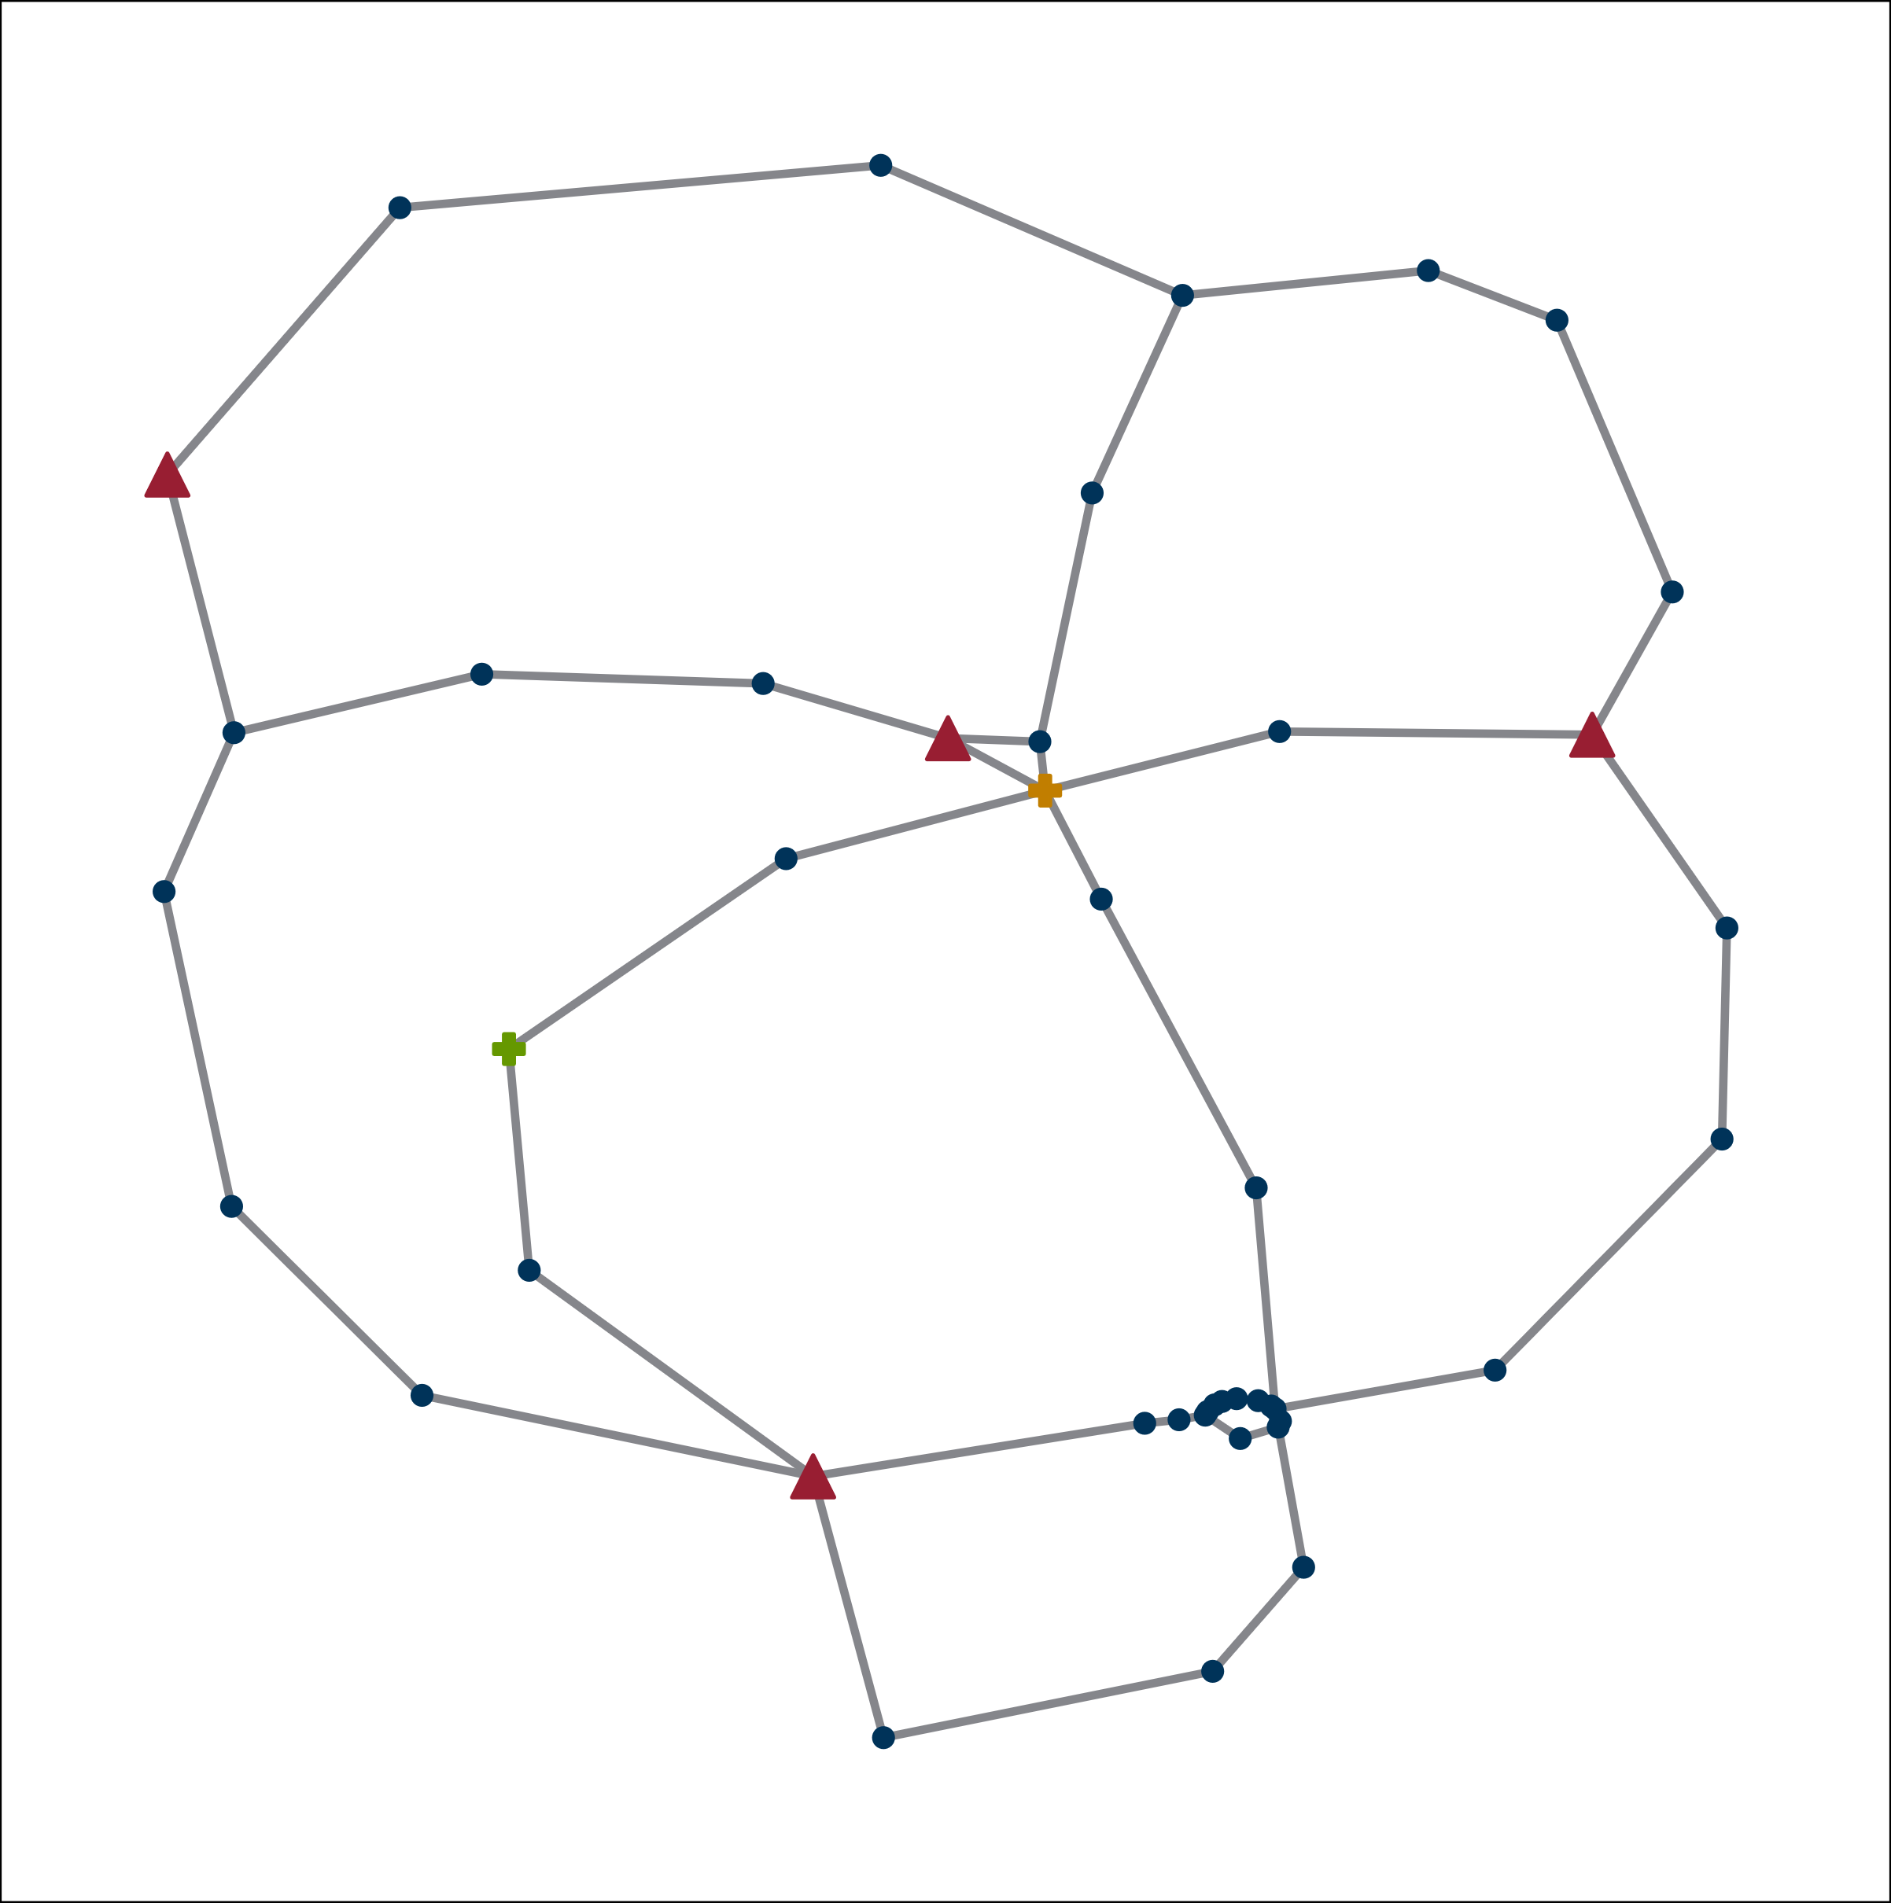

Figure 7 Diagram of the example network studied in this contribution. Regular stations in blue, MGCC and SCC roles attached to the orange station, ACC roles attached to the green station. Actors are found in the stations with the red triangles.

Figure 8 Average availability of each model in the example network

# Conclusion

In this contribution, the communication models identified in [6], based on [9], have been defined. General RBDs were developed, enabling software implementation. These diagrams were applied to a fictional sample communication network associated with a synthetic electrical transmission grid as a proof of concept. It was shown that, when considering only the reliability of communication components, the MPM variant generally has higher availability than the corresponding SPM variant.

Using the framework from [5], this approach can be extended to studies involving non-fictional communication networks, potentially integrating the reliability data of the electrical transmission grid. To enable this, optimized and selected CCMMs must be defined for a sufficiently large set of grid use cases, and reliability data for sensors, actors, and GCCs must be collected. In particular, Markov models for GCCs in CCM-related scenarios need to be developed. Once available, these models will allow for the evaluation of individual CCMMs under various configurations to identify the most reliable solution for single contingencies.

Nevertheless, the presented models contribute to the possibility of optimizing placement and operation of CCM, aiding the transformation of the European transmission grid into more operational efficiency and thus to enlarge the capacity to create a zero-carbon economy.

References

[1] K. Kollenda *et al.,* "Curative measures identification in congestion management exploiting temporary admissible thermal loading of overhead lines," *IET Generation Trans & Dist*, vol. 16, no. 16, pp. 3171–3183, 2022, doi: 10.1049/gtd2.12512.

[2] D. Westermann *et al.,* "Curative actions in the power system operation to 2030," in *International ETG-Congress 2019; ETG Symposium*, 2019, pp. 1–6.

[3] Gesamtverbund InnoSys 2030, *Innovationen in der Systemführung bis 2030.* [Online]. Available: https://​www.innosys2030.de​/​ (accessed: Nov. 7 2024).

[4] B. Musiol, C. Thöne, and M. Zdrallek, "Reliability Calculation for Curative Congestion Management in Transmission Grids with Optical Ground Wire Dominated Communication Networks," in *2024 IEEE PES Innovative Smart Grid Technologies Europe (ISGT EUROPE)*, Dubrovnik, Croatia, 2024, pp. 1–5.

[5] C. Thöne, B. Musiol, and M. Zdrallek, "Modular Construction Kit for Calculating the Reliability of a Grid Operator’s Communication Services," in *2024 18th International Conference on Probabilistic Methods Applied to Power Systems (PMAPS)*, Auckland, New Zealand, 2024, pp. 1–6.

[6] C. Thöne, B. Musiol, and M. Zdrallek, "Reliability-Oriented Routing Metric for OSPF Protocol Applications in Transmission System Operator Use Cases: in press," in *ETG Kongress 2025*: VDE, 2025.

[7] R. Billinton and R. N. Allan, *Reliability evaluation of engineering systems: Concepts and techniques*. Boston: Pitman, 1983.

[8] H.-D. Kochs, *Zuverlässigkeit elektrotechnischer Anlagen*. Berlin, Heidelberg: Springer Berlin Heidelberg, 1984.

[9] Gesamtverbund InnoSys 2030, *Der InnoSys-Systemführungsprozess*. InnoSys 2030 - Innovationen in der Systemführung bis 2030. [Online]. Available: https://​www.innosys2030.de​/​wp-​content/​uploads/​InnoSys_​Systemfuehrungsprozess.pdf (accessed: Nov. 7 2024).

[10] B. Musiol, C. Thöne, and M. Zdrallek, "Algorithmically Creatable Reliability Block Diagrams for Special Protection Schemes According to the Single-Pass Model for Curative Congestion Management: in press," in *ETG Kongress 2025*: VDE, 2025.

[11] F. Möhrke *et al.,* "Kurativ oder präventiv (n-1)-sicherer Betrieb?: Risikovergleich für Übertragungsnetzebene," *ew-Magazin*, 11-12, pp. 74–79, 2019.

[12] K. Kamps *et al.,* "Modelling and Risk Assessment of Special Protection Schemes in Transmission Systems," in *2020 International Conference on Probabilistic Methods Applied to Power Systems (PMAPS)*, Liege, Belgium, 2020, pp. 1–6.

[13] K. F. Schäfer, *Systemführung*. Wiesbaden: Springer Fachmedien Wiesbaden, 2022.

[14] A. Birolini, *Reliability Engineering*. Berlin, Heidelberg: Springer Berlin Heidelberg, 2010.