Machine Learning based Development of Energy Efficient Filters for the Transport of Hydrogen

Amin Zargaran1 | Florian Freese1 | Fabian Hartwig1 | Uwe Janoske1

**Correspondence**

Uwe Janoske

University of Wuppertal

Faculty of Mechanical and Safety Engineering – Fluid Mechanics

Gaußstraße 20

42119 Wuppertal  
Email: [janoske@uni-wuppertal.de](mailto:janoske@uni-wuppertal.de)

1 University of Wuppertal, Wuppertal, Germany

**Abstract**

The increasing demand for hydrogen in the future requires efficient transportation via pipelines. Due to long transportation distances, the hydrogen must be compressed several times to compensate for the pressure losses. Appropriate compressors are required, which must be equipped with filters to ensure the purity of the hydrogen during transportation. In particular, fine oil droplets produced in the oil-lubricated compressors must be removed. The pressure losses of the filters lead to a considerable power loss due to high volume flows of hydrogen. Targeted design of the filter media makes it possible to reduce the pressure loss and thus achieve enormous CO2 savings. These designs require numerical models to reduce development times and offer the possibility for a detailed optimization. The challenge in modeling these filters is to bridge the gap between the large differences in scales between the oil droplets to be separated in the range of a few micrometers and the filter housing covering the filter media, which is in the order of meters. Conventional computational fluid dynamics methods fail due to the immense computing times required to resolve the different scales in one simulation. Efficient numerical tools are therefore required for the economic development of filters. Therefore, machine learning-based approaches for determining the flow field are coupled with particle methods for calculating the oil droplets and oil films. Physics Informed Neural Networks (PINNs) are used to describe the flow field. This allows the application of the numerical method to larger filter structures which can be solved in acceptable computing times and thus enables the numerical optimization of fiber and filter structures that lead to an energy-efficient transport of hydrogen.

**Keywords**

Filtration, CFD, PINN, SPH, Coupling

# Introduction

The separation of particles from gases and liquids is essential in many industrial sectors to maintain product quality and comply with legal regulations aimed at reducing emissions from industrial plants. The method of choice is usually filtration, the importance of which came to the forefront during the COVID pandemic. Filter media used for particle separation typically consist of a large number of small, irregularly arranged fibres. The separation of particles within the filter medium primarily occurs due to the physical effects of inertia, diffusion, and geometric blocking within the medium. This type of filtration is known as depth filtration and is capable of removing finest particles from the gas flow with high separation efficiency.

However, a disadvantage is the pressure loss that occurs during the flow through the filter, leading to a reduction of the flow rate that must be compensated by fans, compressors, or similar equipment. Therefore, the design objective of filters is to achieve maximum separation efficiency with minimal pressure loss. Especially in applications with high volumetric flow rates, the development of specialized media is necessary—such as for the transport of hydrogen, which is gaining importance in the context of the energy transition. Germany's pipeline network for transporting compressed hydrogen spans approximately 510,000 km, and due to friction-induced pressure losses, pumping stations are required every 100 to 400 km. However, during compression in these stations, contaminants in the form of particles or aerosols can form, which must be removed for further use via so-called coalescence filters. To minimize energy consumption during the separation of aerosols using fibre-based filter materials, these materials must meet very high-performance standards. Given that hydrogen will be integrated into the existing gas network in the future, its distinct physical properties compared to natural gas must be considered in the new material requirements. By carefully designing the filter media and filter elements, the pressure drop of the installed filter can be significantly reduced, which could result in a reduction of over 8 million tons of CO₂ by 2050. In this way, energy-efficient filtration can make a significant contribution to realizing the energy transition.

Oil droplet separation is achieved using coalescence filters. Coalescence refers to the merging of fine aerosol droplets into larger liquid drops and is used as a filtration principle for removing fine oil droplets from compressed air that may arise during compression. In the first step of the filtration process, the droplets adhere to a surface - such as fibres - where they grow into larger drops until the entire porous material is saturated with oil. These large drops then flow downward due to gravity on the downstream side of the material, thereby removing the oil from the compressed air flow. Depending on the efficiency of the filter medium, a higher or lower level of purity is achieved. The amount of oil remaining in the compressed air is known as the oil carry-over and indicates the quantity left after filtration. As the porous material becomes saturated with oil, an increasing pressure is required to continue forcing the air through the filter medium. This results in different pressures before and after the saturated filter, known as the differential pressure, or pressure loss/saturation pressure. The lower the pressure loss, the less energy is needed for the medium to be flown through. Achieving energy-efficient operation while maintaining high separation efficiency requires detailed insight into newly developed media regarding separation, coalescence, drainage, and re-entrainment across various size scales—from individual fibres to the entire filter. These insights can only be fully accessed through numerical modelling. By considering coupled effects across different scales, both local phenomena can be understood and optimized, and their interactions at larger scales can be evaluated. The numerical description of the processes involved in droplet separation and transport on fibres has only been explored in a few studies due to computational challenges. Most studies focus on individual fibre systems, such as the work by Bodziony & Marschall [1], who used a phase-field method to examine droplet motion on a single fibre. The movement of single droplets on vibrating fibres was examined by Schwarzwälder et al. [2] and Freese et al. [3] experimentally and numerically, showing different mechanisms of droplet separation. For modelling filtration processes in gas-liquid systems, methods based on Lagrangian particle tracking are typically used [4-6]. Seraj and Yahya [7] studied droplet separation using Euler-Lagrange models without detailing droplet or film formation. To describe the interface between liquid and gas, Volume-of-Fluid (VOF) models are used, for example, by Abishek et al. [8]. Chaudhuri et al. [9] used a Eulerian model to numerically describe the processes in a coalescence filter and were able to make both transient and steady-state predictions regarding separation and pressure loss using macro models. Baumann et al. [10] applied a macroscopic approach to solve the mass balances for the wetting and non-wetting phases, integrating this into the commercial CFD code Ansys Fluent.

In summary, while studies exist in this field, they mostly focus on individual systems and do not account for the complex interactions within the filter structure. Furthermore, the topic has not been explored in the context of optimizing structures for reduced pressure loss and CO₂ emissions in hydrogen filtration. As part of the project, a new innovative approach is being introduced that addresses the previous challenges related to different scales and computational time. This enables a better assessment of the local structural variations in a simulation model that have previously hindered accurate numerical representation of filtration processes. A deep fundamental understanding of these processes ultimately allows for targeted optimization. This provides a suitable development methodology that facilitates and accelerates the development and optimization of new media, as well as their transferability to other applications.

# Simulation approach

# One of the main difficulties for the numerical modelling and simulation of filtration processes is the huge difference in geometric scales. Fig. 1 shows an example of the different scales ranging from a filter media which can be in the order of meters *O(100 m)* to a representative element of various fibres (middle) in the order of 100 µm *O(10-4 m)* and finally to the scale of the fibres *O(10-6 m)* or even smaller scales of the particles.

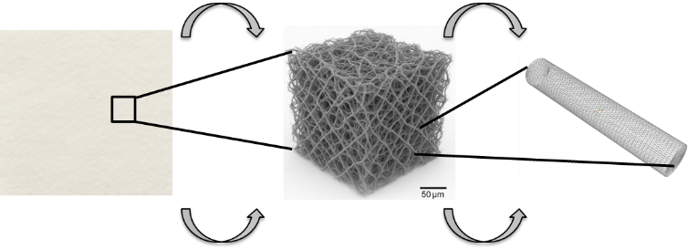

Figure 1 Different scales in filtration problems: left: filter media O(100 m), middle: representative element of different fibres O(10-4 m), right: single fibre O(10-6 m)

# If a complete filter element should be resolved by a computational mesh, this is not feasible in reasonable time scales even on high performance computers. Current modelling approaches focus on representative elements to derive the characteristics of pressure drop and filtration efficiency which are later extrapolated to larger filter media. Nevertheless, these models require as well large simulation times and are not suitable for fast designs of filter media or even optimization of them. Therefore, the need for new simulation approaches considering larger domains in reasonable simulation times is a must for new generations of effective filter media. One of the key elements for the large simulation times is the change of the geometry during the filtration process which requires a permanent recalculation of the flow field. Another drawback of the simulation is the complex geometry of filter elements which are very difficult to mesh in acceptable mesh qualities. These two drawbacks - long simulation times of the flow and difficulties in meshing – lead to this new approach, presented in Fig. 2.

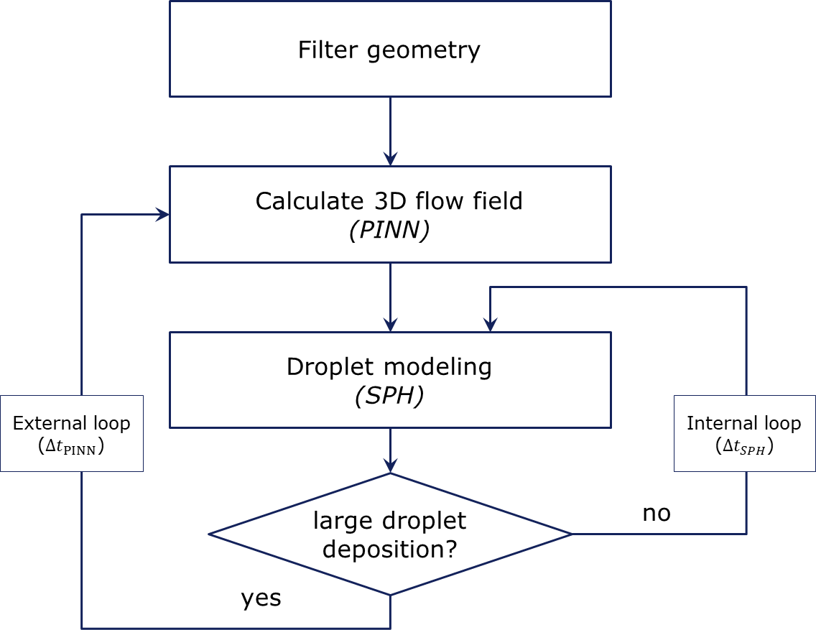

Figure 2 Work flow of the combined PINN / SPH approach

To avoid long simulation times, a machine learning based approach based on Physics Informed Neural Networks (PINNs) is used. A particle method to calculate droplets and fluid films avoids the meshing of the geometry. After the definition of the filter geometry which must be defined in the format of a STL (Standard Tessellation Language), the flow field is determined by a trained PINN model in the range of seconds. Based on this flow field, the droplets and films are derived by a Smoothed Particle Hydrodynamics (SPH) model [11-13]. If droplets are deposited on a fibre, the geometry for the gas flow changes, requiring the determination of a new flow field of the gas phase. If no changes of the geometry appear, a new set of droplets is calculated. This process is repeated until the final filtration time will be reached. The simulation models used will be explained in the next section.

## Simulation model

The simulation domains presented in this work are shown in Fig. 3. Four different arrangements of fibres with varying porosities are used in this study. The geometries are generated by a random distribution of the fibres for the pre-defined porosities by an in-house code. The fibres with a fibre diameter df between 2 and 4 µm are in a channel with the dimension 3.3 dh x dh x dh µm using a value of dh=30 µm. A gas flow velocity of 0.35 m/s is set at the inlet, whereas the pressure is fixed at the outlet to zero. The side walls have slip boundary conditions. Gas is assumed to be incompressible with the density of the gas **=0.0826 kg/m3 and the kinematic viscosity *n*=1.06·10-4 m²/s. The flow field can be described by two dimensionless numbers, the Reynolds number of the flow around the fibre (1) and the channel flow (2).

Ein Bild, das Entwurf, Zeichnung, Kunst enthält.

Figure 3 Filter elements with different porosities

$Re_{F}=\frac{d_{f}u}{ν}$ (1)

$Re_{ch}=\frac{d_{h}u}{ν}$ (2)

## Governing equations

The flow is assumed to be isothermal, incompressible and steady state. As the velocities in filtration are very small and the sizes are small as well, the inertia terms in the momentum equations are neglected, resulting in the well-known Stokes equations consisting of the continuity (3) and the momentum equation (4) with the pressure p and the velocity vector **u** (with the components u, v and w in x, y and z-direction):

$∇⋅u=0$ (3)

$u⋅∇u=\frac{1}{ρ}∇p+\frac{μ}{ρ}∇^{2}u$ (4)

To solve the motion of the droplets, a meshless Smoothed Particle Hydrodynamics (SPH) method is applied. In SPH, field variables A are first approximated by a continuous kernel function W with smoothing length h (5). The smoothing length defines the radius of influence around each particle. This kernel approximation is then discretized by summing over neighboring particles, yielding the particle approximation (6), where mj and ρj denote the mass and density of particle j, and **r**i and **r**j their positions:

$〈A(r)〉=\int{A\left(r^{'}\right)W\left(r-r^{'},h\right)dr'}$ (5)

$〈A(r_{i})〉=\sum_{j}{\frac{m_{j}}{ρ_{j}}A_{j}W(r_{i}-r_{j},h)}$ (6)

## Simulation methods

The simulation methods used, are explained in this section:

*Physics-Informed Neural Network (PINN)*

Physics-Informed Neural Networks (PINNs) [15-16] are a novel method of using Machine-Learning tools without using test data for learning. Especially in fluid mechanics, PINNs can be used to determine flow fields by using the Navier-Stokes equations for learning. Fig. 4 shows a schematic representation of a PINN with a neural network (NN) on the left, which using the coordinates x, y and z as an input layer. The output of the NN are the velocities u, v, w and the pressure p. Using the automatic differentiation, the gradients are available which are used to determine the loss function, i.e. the error in the Navier-Stokes equation. Furthermore, boundary conditions are considered in the loss function resulting in the total loss. Neural networks are susceptible to spectral bias, meaning they tend to learn the low-frequency components of a target function more rapidly than its high-frequency components [20]. As a result, convergence to high-frequency solutions is not guaranteed, even when employing deeper architectures or prolonged training durations. A promising strategy to mitigate this limitation involves input encoding, whereby the input data are transformed into a higher-dimensional feature space using high-frequency functions. One effective method for achieving this is through Fourier Feature Neural Networks (FF-NNs) [21]. In FF-NNs, the original inputs are mapped onto a set of periodic functions, such as sine and cosine, in a process known as Fourier feature embeddings. These embeddings convert input coordinates—such as spatial variables (x, y, z) or temporal variables (t)—into a higher-dimensional representation using trigonometric functions. This transformation equips the subsequent multi-layer perceptron (MLP) with the capacity to better capture and represent high-frequency variations in the target function. Similarly, for densely packed filters that contain pores of varying sizes through which fluid accelerates, FF-NNs can enhance the method’s performance by capturing regions with high velocity gradients.

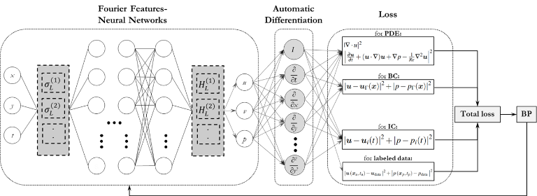

Figure 4 Schematic drawing of a Fourier Features Physics-Informed Neural Network

*Smoothed Particle Hydrodynamics (SPH)*

Smoothed Particle Hydrodynamics (SPH) [17] is a mesh-free, entirely Lagrangian numerical method for simulating fluid flows. The fluid domain is represented by a set of discrete particles that carry physical properties such as velocity, pressure, density, and mass. SPH relies on an interpolation technique that allows field variables to be approximated at each particle location by smoothing over neighbouring particles. This is achieved in two stages. Initially, a continuous smoothing approximation is employed, utilising a kernel function. Subsequently, a discrete particle approximation is implemented, employing summation over particle pairs, as outlined by Liu et al. [17]. The method captures local interactions by assigning each particle an influence radius defined by the smoothing length. SPH is mass-conserving and well-suited for problems with complex geometries or free surfaces, since only the regions of interest need to be discretised. Due to its Lagrangian nature, no computational grid is required, which results in a highly efficient computational method. The advantages listed above make SPH attractive for engineering applications such as filtration processes.

## Validation

For the validation of the PINN model a comparison of the well know flow past a single fibre is used. For the assumption of small Reynolds numbers of the fibre (ReF<1), the influence of inertia terms can be neglected and the analytical equation of Lamb [18] can be used. The Kaplun [19] equations which was extended to higher Reynolds numbers can also be applied. Fig. 5 shows the drag coefficient, CD, plotted against the Reynolds number of the fibre, ReF, which is defined as the dimensionless drag force on the fibre FD related to the area of the cylinder and the stagnation pressure with the density of the gas  and the velocity of the gas u:

$c_{D}=\frac{F_{D}}{\frac{1}{2} ρπ l d_{f} u^{2}}$ (7)

The comparison between PINN and the Kaplun correction shows a very good agreement confirming the validity of the PINN approach.

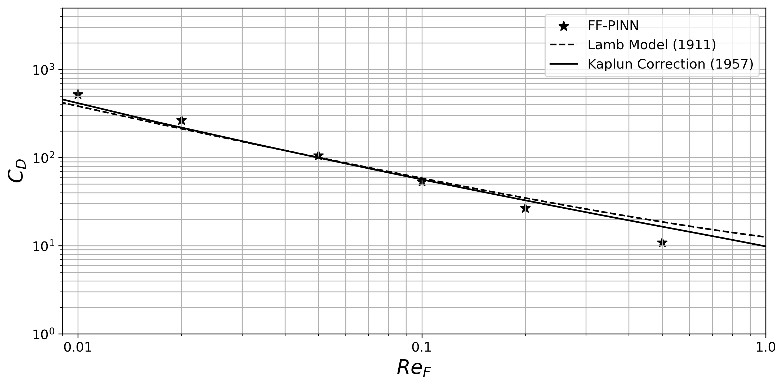

Figure 5 Comparison of the drag coefficient CD plotted against the Reynolds number of PINN with analytical equations of Lamb [18] and Kaplun [19]

Fig. 6 shows a comparison for a Reynolds number of 0.1 between CFD simulation and PINN results for the velocity components and as well as the pressure field. Aside from very minor and negligible differences, the results obtained from the PINN approach show good agreement with the CFD simulations.

|  |  |  |
| --- | --- | --- |
| CFD | PINN |  |
|  | | |

Figure 6 Comparison of the velocity components and the pressure for the flow around a single fibre between CFD and PINN

# Simulation results

Fig. 7 und 8 show the velocity magnitude and pressure fields for different cross sections for a filter array at the beginning of the filtration process, i.e. with no deposited droplets. Fig. 7 shows the velocity magnitude and the pressure for a Reynolds number of the fibre of 0.1 and a porosity of 96.4%. One can see the pressure gradient across the filter media in the pressure field (top row). The velocity field shows the complex flow through the array of the fibres demonstrating the difficulties of resolving the flow through the fibres. This can be seen as well in Fig. 8 where the velocity field is shown for the four different porosities. As real filter structures can be regarded as randomly arranged fibre arrays, the need for looking at larger geometries to have a statistical based result becomes obvious.

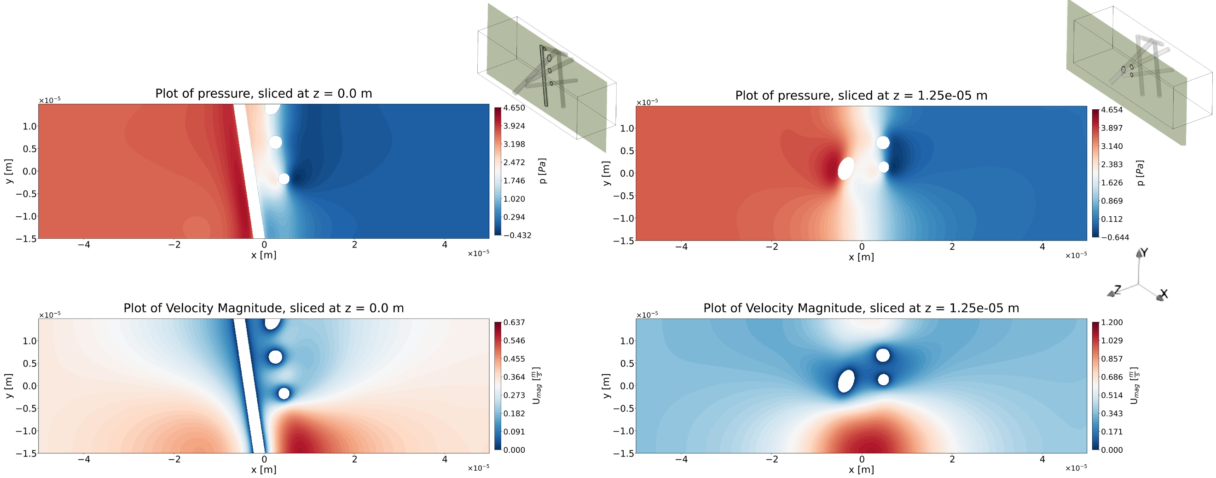

Figure 7 Pressure (top) and velocity magnitude (bottom) fields plotted on two different slices for a porosity of 96.4% and the Reynolds numbers related to the fibre Ref=0.01 and the channel Rech=0.1

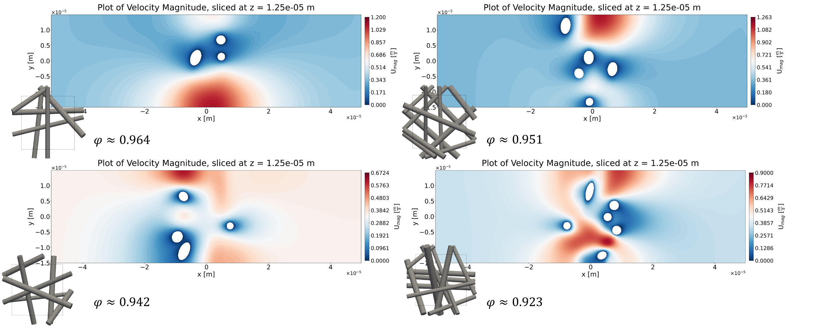

Figure 8 Comparison of the velocity field for different porosities and a Reynolds numbers related to the fibre Ref=0.01 and the channel Rech=0.1

In Fig. 9 the pressure drops over the filter array is plotted against the porosity. The pressure values are normalized to the value for the porosity of 96.4%. A reduction of a porosity and therefore the available void volume for the gas flow leads to a nearly linear increase of the pressure drop. As the Stokes assumption is used, the pressure drop should be linear, but due to the small structures a slight deviation by local differences can be observed.

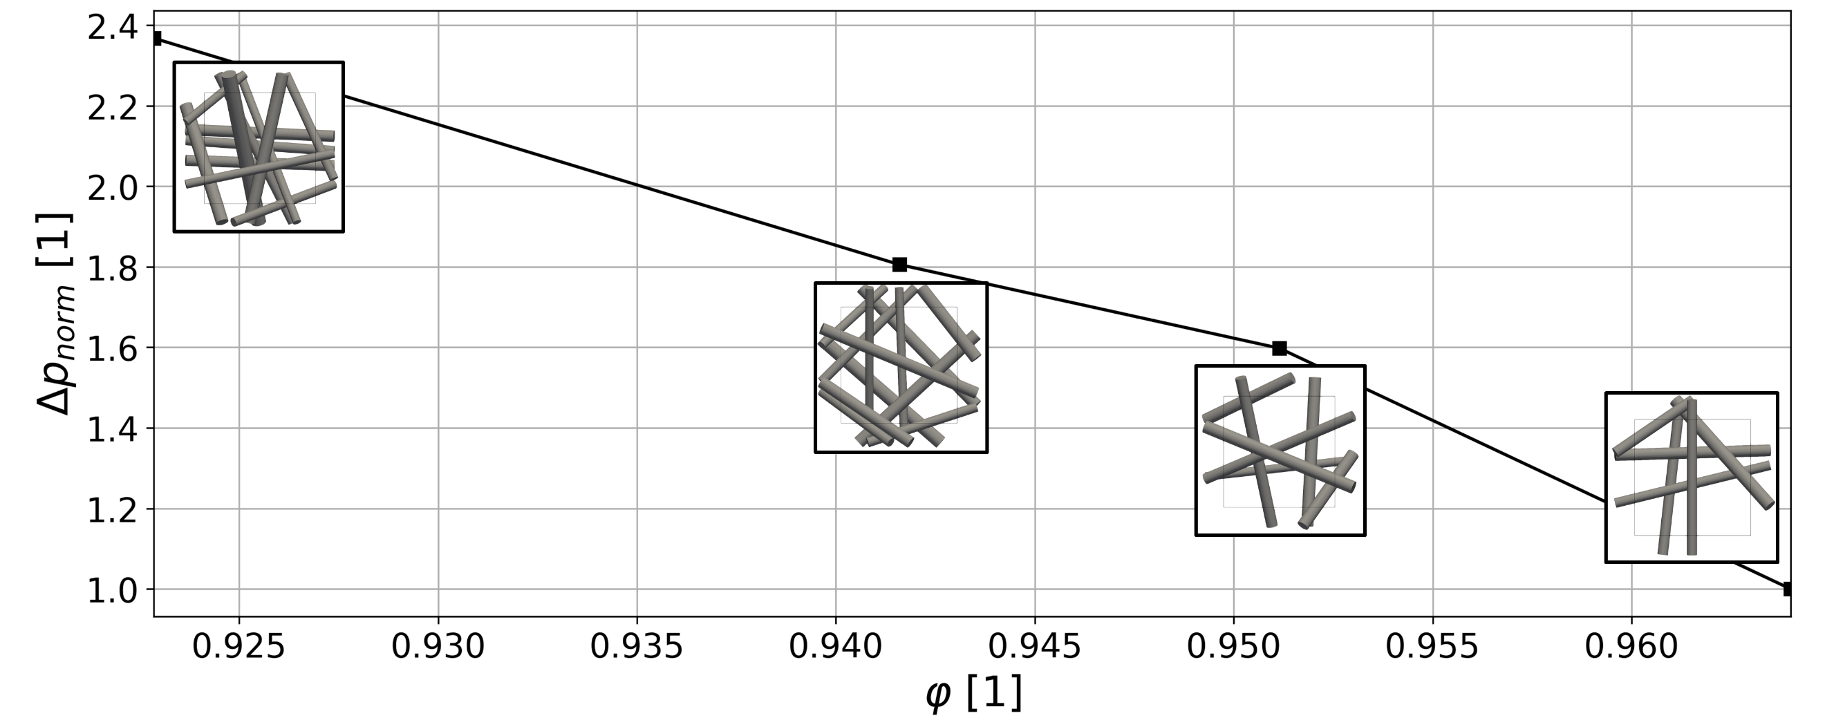

Figure 9 Normalized pressure drop p(*φ*)/p(*φ* =0.964) plotted against the porosity *φ*

Next, the PINN model is employed to simulate the flow field during the filtration process, specifically updating the flow field as droplets are deposited onto the filter. For this purpose, the filter with porosity *φ*=0.964 is selected, and three successive random deposition events are investigated. These depositions are illustrated in Fig. 10.

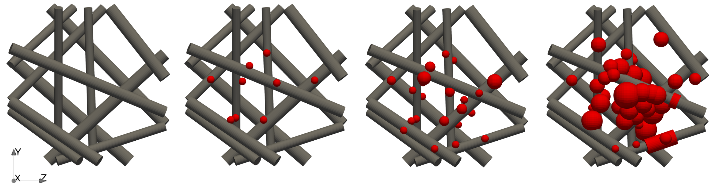

Figure 10 Temporal representation of the droplet deposited (depicted in red colour) on the fibres with porosity *φ*=0.964.

Fig. 11 shows the velocities in two different cross sections for varying droplet depositions. One can clearly see the massive influence of the particle depositions on the flow field demonstrating the need for a coupled simulation and renewal of the flow field calculation during the filtration time.

# Conclusion and outlook

A combination of SPH and PINN was used to model the filtration process of oil droplets. The method was setup successfully and validated against data from literature for the flow around a single fibre as well as for the flow through a filter media validated with CFD results. In the next steps, the simulation domain is going to be extended to model larger filter media and filter systems in economic timescales which becomes possible by this new coupling method making it a new tool for the development of new filter media with reduced pressure drops. This helps to reduce the amount of CO2 dramatically.

Remark: Parts of the paper are written with the help of ChatGTP.

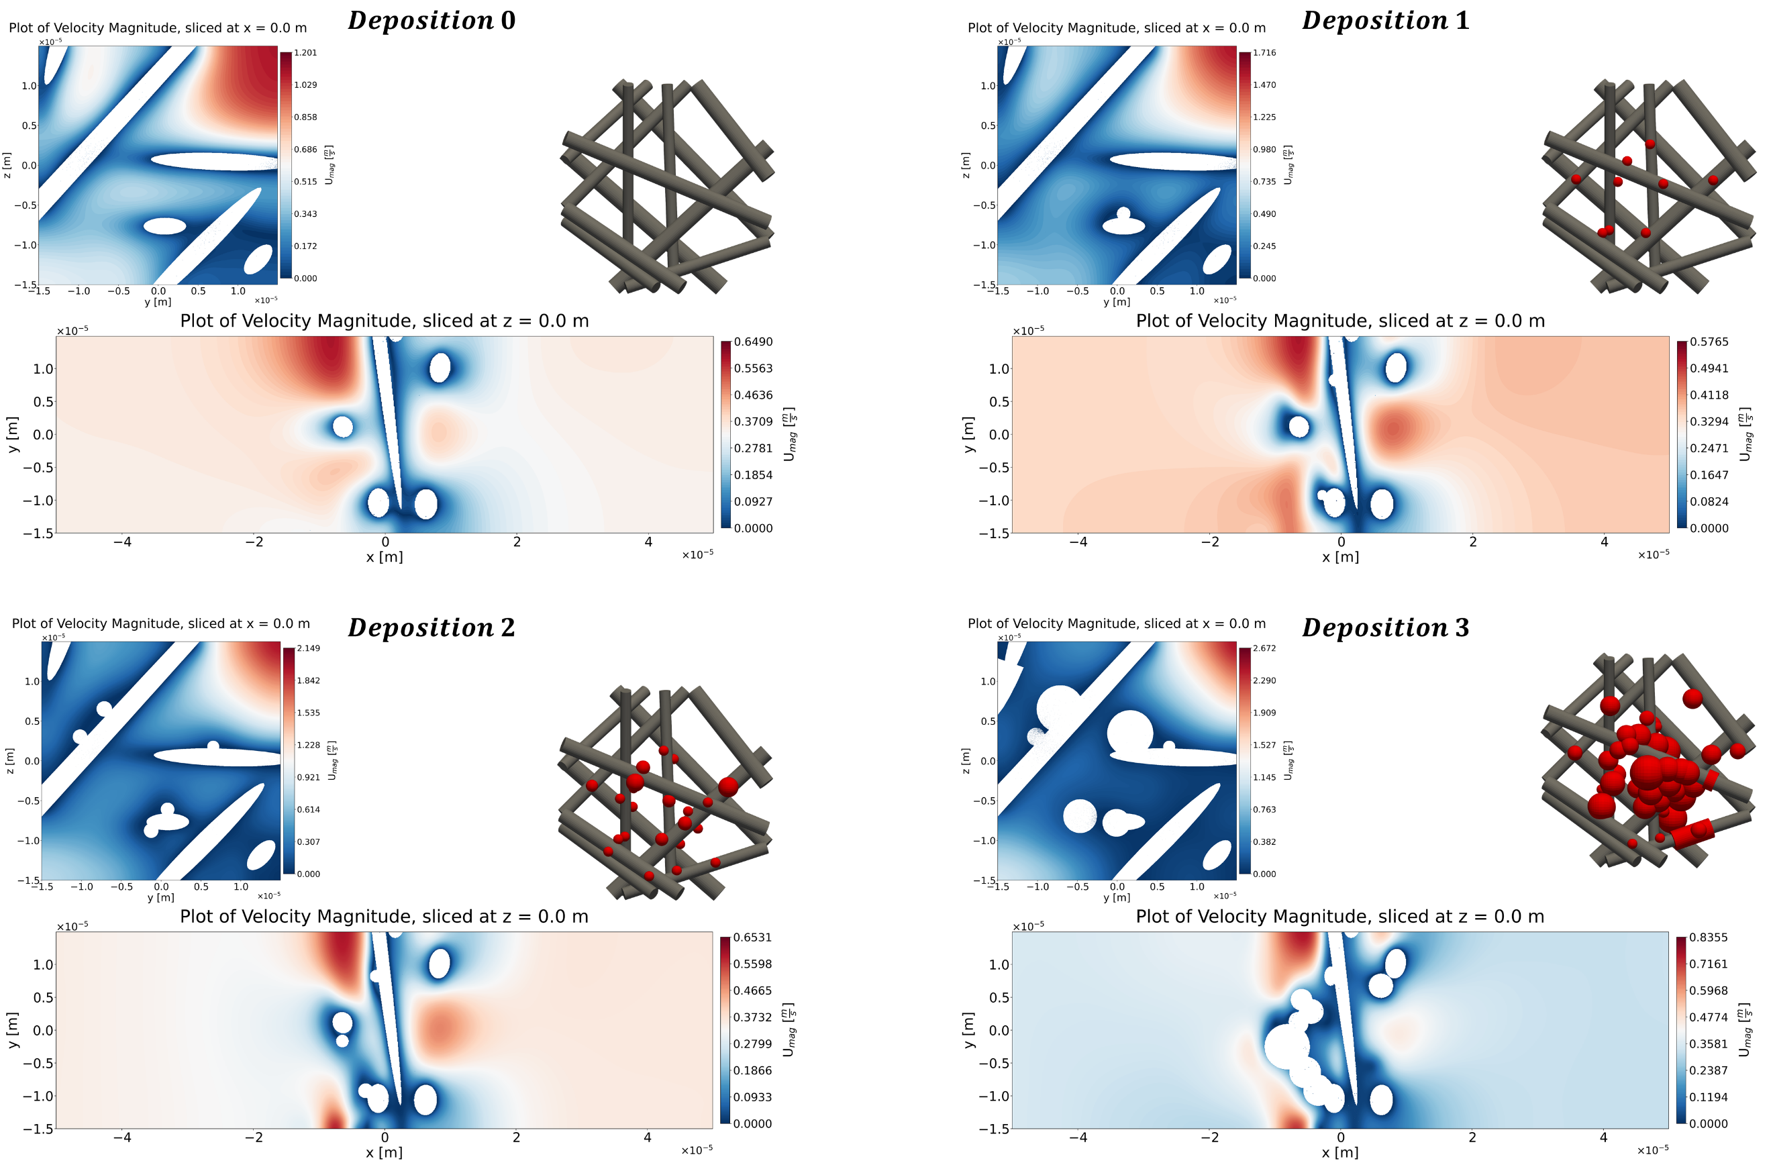

Figure 11 Flow field in two different slices for varying droplet depositions in the filter

References

1. Bodziony, F.; Wörner, M.; Marschall, H. (2023) *The stressful way of droplets along single-fiber strands: A computational analysis*. Physics of Fluids 35 (1).
2. Schwarzwälder, A.; Freese, F.; Meyer, J.; Loganathan, K.; Tietze, H.; Dittler, A.; U. Janoske (2024) *Experimental and numerical investigation of droplet-fiber interaction on mechanically excited fiber*. Physics of Fluids 36 (3).
3. Freese, F.; Schwarzwälder, A.; Janoske, U.; Dittler, A. (2025) *Transition from clamshell to barrel shaped oil droplets on a single oleophobic fiber through periodic mechanical excitation*. Separation and Purification Technology 376(2).
4. Mead-Hunter, R.; King, A. C.; Kasper, G. Mullins, B. J. (2013) *Computational fluid dynamics (CFD) simulation of liquid aerosol coalescing filters*. Journal of Aerosol Science 61, pp. 36–49.
5. King, J.; Mullins, B. J.; Lowe, A. G. (2010) *Discrete Particle Tracking in Fluid Flows for Particulate Filter Simulations*. In Proceedings of the 6th Australasian Congress on Applied Mechanics, pp. 150–158.
6. Mead-Hunter, R.; Mullins, B. J.; King, A. C. (2011) *Development and Validation of a Computational Fluid Dynamics (CFD) Solver for Droplet-Fibre Systems*. In Proceedings MODSIM.
7. Seraj, M.; Yahya, S. M. (2019) *Numerical Study of Droplet Motion inside Nonwoven Fibrous Media*. CFD Letters 11, pp. 72–79.
8. Abishek, S.; Mead-Hunter, R.; King, A. C.; Mullins, B. J. (2019) *Capture and re-entrainment of microdroplets on fibers*. Physical Review E 100.
9. Chaudhuri, J.; Boettcher, K.; Ehrhard, P (2021) *Numerical investigation of coalescence filtration: Multiphase flow through fibrous structures*. Separation and Purification Technology 257.
10. Baumann, A.; Hoch, D.; Behringer, J.; Niessner, J. (2020) *Macro-scale modeling and simulation of two-phase flow in fibrous liquid aerosol filters*. Engineering Applications of Computational Fluid Mechanics 14(1).
11. Härdi, S.; Schreiner, M.; Janoske, U. (2019) *Enhancing smoothed particle hydrodynamics for shallow water equations on small scales by using the finite particle method*. Computer Methods in Applied Mechanics and Engineering, vol. 344, pp. 360–375.
12. Härdi, S.; Schreiner, M.; Janoske, U. (2020) *Simulating thin film flow using the shallow water equations and smoothed particle hydrodynamics*. Computer Methods in Applied Mechanics and Engineering 358.
13. Härdi, S.; Schreiner, M.; Janoske, U. (2021) *On a new algorithm for incorporating the contact angle forces in a simulation using the shallow water equation and smoothed particle hydrodynamics*. Computers and Fluids 215.
14. Zargaran, A.; Janoske, U. (2020) *Development of an algorithm for reconstruction of droplet history based on deposition pattern using computational fluid dynamics and convolutional neural network*. Computer Methods in Applied Mechanics and Engineering 372.
15. Lorenzen, F.; Zargaran, A.; Janoske, U. (2024) *Utilizing Physics-Informed Neural Networks for Modeling 3D Fluid Flows Incorporating Parametric Boundary Conditions*. In: Benim, A.C., Bennacer, R., Mohamad, A.A., Oclon, P., Suh, SH., Taler, J. (eds) Advances in Computational Heat and Mass Transfer. ICCHMT 2023. Lecture Notes in Mechanical Engineering. Springer.
16. Lorenzen, F.; Zargaran, A.; Janoske, U. (2024) *Potential of physics-informed neural networks for solving fluid flow problems with parametric boundary conditions*. Physics of Fluids 36 (3).
17. Liu, M. B.; Liu, G. R. (2010) *Smoothed particle hydrodynamics (SPH): an overview and recent developments*. Archives of Computational Methods in Engineering, 17(1), pp. 25–76.
18. Lamb, H. (1911). XV. *On the uniform motion of a sphere through a viscous fluid*. The London, Edinburgh, and Dublin Philosophical Magazine and Journal of Science, 21(121), 112–121.
19. Kaplun, S. (1957). *Low Reynolds Number Flow Past a Circular Cylinder*. Journal of Mathematics and Mechanics, 6(5), 595–603.
20. Rahaman, N., Baratin, A., Arpit, D., Draxler, F., Lin, M., Hamprecht, F., Bengio, Y., Courville, A. (2019, May). *On the spectral bias of neural networks*. In International conference on machine learning (pp. 5301-5310). PMLR.
21. Tancik, M., Srinivasan, P., Mildenhall, B., Fridovich-Keil, S., Raghavan, N., Singhal, U., Ramamoorthi, R., Barron, J., Ng, R. (2020). *Fourier features let networks learn high frequency functions in low dimensional domains*. Advances in neural information processing systems, *33*, 7537-7547.