Analysis of the Reliability of Communication Services of a Transmission System Operator Considering Dynamic Routing for Enhanced Availability
Christian Thöne1 | Bartosz Musiol2 | Markus Zdrallek2
Correspondence
Christian Thöne
Amprion GmbH
Robert-Schuman-Str. 7
44263 Dortmund
Email: christian.thoene@amprion.net

1 Asset Management, Telecommunications & Op Control Centers, Network Management, Amprion GmbH, Dortmund, Germany
2 Institute of Power Systems Engineering, University of Wuppertal, Wuppertal, Germany
Abstract
The transformation of the energy system towards a climate-neutral, decentralized energy supply is generating novel challenges for German transport system operators. On the one hand, electrical grids are being expanded and, on the other hand, new operating modes are being developed. Curative congestion management, for example, is a novel operating mode that is heavily dependent on the availability of a transport system operator’s communication network. The functioning of curative congestion management depends, among other things, on a permanent exchange of data between sensors, actuators and grid control centers. This contribution examines the impact on the availability of services that use dynamic routes. The results are compared with common availability classes and classified accordingly. The outcome is that for some availability classes, alternative static routing is sufficient, while dynamic routing must be used, especially for higher availability classes. These results can be used to determine whether static or dynamic routes should be used to transmit data for curative congestion management.
Keywords
Reliability, dynamic routing, communication network, curative congestion management

Introduction
The decarbonization of Germany necessitates the expansion of renewable energy sources while concurrently decommissioning nuclear and coal power plants. Consequently, the geographical power feed-in locations are changing, prompting transmission system operators (TSO) in Germany to expand and optimize the utilization of the electrical transmission grid at several locations [1]. Research projects such as InnoSys2030 demonstrate that the coordinated implementation of curative congestion measures, alongside increased automation, can facilitate higher electrical transmission grid utilization without compromising system stability [2]. These measures require a permanent and reliable data connection before and during a curative measure [3]. Data connections can link the data source and their corresponding sinks through various types of routes like static and dynamic. These types of routes influence the availability of the connection, as the reliability data (RD) vary between static and dynamic routes. The reliability of data connections is of particular importance for TSO in the context of curative congestion management (CCM). CCM is employed to address bottlenecks in the electrical grid promptly as they arise [4]. They necessitate data connections to facilitate the exchange of signals between actuators, sensors, and grid control centers (GCC) [5]. The established connections between the data source and sink are formally designated as a service. Prior studies have focused on static routes [6]. This contribution explores the extent to which the availability of a route is influenced by dynamic routing and the conditions which a TSO’s communication network (CN) must meet for dynamic routing to be utilized.
Therefore, the approach in [6] is adopted and further developed with a focus on dynamic routing. The purpose is to develop a model that combines service availability requirements and the minimum number of routes with adjusted reliability metrics through CN protection mechanisms. This involves analyzing which network protection mechanisms are relevant for dynamic routes and how these influence the reliability data of routes. Furthermore, the contribution investigates how many alternative routes must exist in a dynamic network to hit a service-specific availability class (AC) [7]. The findings are validated in an example CN that exhibits the characteristics of a CN of a TSO.
Chapter 2 delineates the method and the boundary conditions that must be fulfilled in order to ascertain the availability of dynamic routes, a topic that is subsequently explored in the Chapter 3. In the final Chapter 4, the results and findings are succinctly summarized and evaluated.

Derivation of the method to calculate the availability of dynamic routes
The transmission of data between a data source and a data sink is usually facilitated through routes, which can be classified as either static or dynamic. The route describes the path of the data through a CN. A static route is a manually configured path that remains constant and does not undergo alterations due to external conditions. Potential external conditions can be the establishment of new connections or the failure of the previous route due to a malfunction [8].
Dynamic routes have the property of automatically selecting a path through a CN and can so react to changes in the CN [6]. The parameters that determine the selection of a route by a CN are defined by the selection of the routing protocol (e.g., open shortest path first (OSPF) [9]) and its configuration. Within this depicted domain, a CN operates with a high degree of autonomy. These options enable a dynamic CN to respond to faults and select alternative paths for the connection between the data source and the sink. The CN response consists of fault detection and convergence time and depends on the selected protocol.
The convergence time the is duration it takes for a CN to respond to a change in the route, such as a link failure, and propagate this information to all routers in the CN. Once all routing tables have stored the new information, the CN is back in balance. During the occurrence of CN convergence, the communication experiences a temporary interruption. The size of the network and the selected routing protocol have a significant influence on the convergence time. The convergence time can take several tens of seconds [10].
To reduce the time required to restore the route, additional mechanisms known as fast reroute (FRR) are implemented. A prevalent FFR mechanism is the Bidirectional Forwarding Detection (BFD) protocol [11]. In the OSPF protocol, so called ”hello/dead packets” are required for the status monitoring of a link (i.e., a direct connection between two neighboring routers) and are sent at an interval of $t_{OSPF}=30s$. In contrast, the BFD protocol offers the capability to perform status monitoring of links with a frequency of $t_{BFD}=30ms$. The BFD protocol works independently of a particular routing protocol. This feature renders the BFD protocol highly versatile [10], [11].

The CN of a TSO is utilized for a broad spectrum of services. A range of services is available, including data exchange, which is necessary for the management of congestion in a curative manner, as well as protection communication connections [5]. The various services have different levels of importance. Given the correlation between high availability and elevated resource requirements, it is logical to allocate services to appropriate AC. The determination of the appropriate availability for a given service is the scope of the service owner. The AC depicted in Table 1 represent the conventional classifications employed by data network operators (e.g., an internet service provider) to assess the availability of services within a Communication Network [7].
Table 1 Availability class according to [7]
Availability class (AC) | Description | $P_{AC}$ in %
AC 0 | Without guaranteed availability | < 99
AC 1 | Normal availability | 99
AC 2 | Increased availability | 99,9
AC 3 | High availability | 99,99
AC 4 | Highest availability | 99,999
AC 5 | Availability under extreme conditions | > 99,999

Error detection and recovery in communication networks
The identification of errors and the subsequent initiation of remedial measures constitute the fundamental pillars of any effective troubleshooting process. Availability is, in general, comprised of two key values: the mean time between failure (MTBF) and the mean time to repair (MTTR). [12]. The MTBF value is specific to the asset in question, whereas the MTTR value is contingent on factors such as travel times to the site of operation and the availability of spare parts. The MTTR is a process-dependent value. The mathematical correlation between $H\left(\overline{Z}\right)$, $T\left(\overline{Z}\right)$, MTBF and MTTR is demonstrated in Equations (1) and (2). According to [13] the approximation for $H\left(\overline{Z}\right)$ is permissible.
$$\begin{aligned}H\left(\overline{Z}\right)≈\frac{1}{MTBF}\#\left( SEQ num 1\right)\end{aligned}$$
$$\begin{aligned}T\left(\overline{Z}\right)=MTTR\#\left( SEQ num 2\right)\end{aligned}$$
In the context of an electrical grid, the overarching objective in the event of a fault is to facilitate the restoration of power supply to the end user with maximum practicality. This is typically accomplished by implementing switching measures as opposed to rectifying the defective asset. This applies only to the model, of course in reality, the defective asset is replaced in parallel. Consequently, the MTTR is the duration required to restore power during the assessment of the reliability of electrical grids in such instances. [14].
In the context of static routes within CN, manual mechanisms are initiated in the event of an interrupted data transmission to facilitate the restoration of the data connection. The corresponding MTTR values are presented in Table 2.
Table 2 Exemplary reliability data of the used components from the example communication network [6]
Device | $H\left(\overline{Z}\right)$ in $1/a$ | $T\left(\overline{Z}\right)$ in $h$ | $P\left(\overline{Z}\right)$ in %
ICT-S | 0,1022 | 4 | $$4,67⋅{10}^{-3}$$
ICT-S Transit | 0,1018 | 4 | $$4,65⋅{10}^{-3}$$
OPGW  (100 km) | 0,01 | 120 | $$1,37⋅{10}^{-2}$$
FO-Cable (20km) | 0,04 | 19,62 | $$8,96⋅{10}^{-3}$$

In the context of dynamically routed CN, the implementation of routing protocols capable of detecting and rectifying errors within a brief timespan is imperative. The fundamental principle underpinning this process is analogous to the procedure in an electrical network. In CN, an automated link switchover is implemented, resulting in the "restoration of service to the end user." In the context of CN, the term "link recovery time” (LRT) is more accurate. The MTTR value for dynamic routes corresponds to the LRT. The LRT value is considerably lower than the repair time for static routes (see Figure 1). Dynamically routed CNs exhibit a notable advantage in that services using them can draw on inherent self-healing capabilities in the event of a fault.
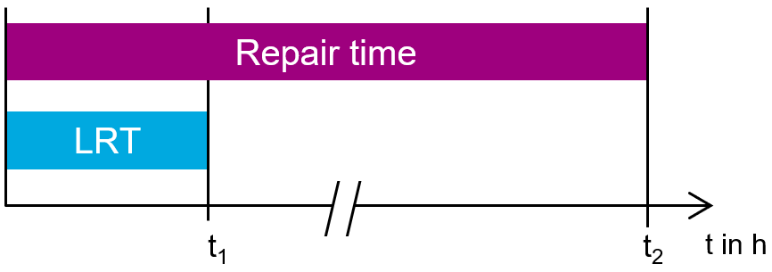
Figure 1 Comparison of the rime required for restoring supply between repair time and LRT.

Example communication network
An exemplary CN has been established and examined. The components of the communication network were utilized in conjunction with the reliability data from Table 2. The individual connections are structured in function blocks according to [6] and calculated according to [13] with regard to their availability.
As depicted in Figure 2, the schematic layout from the CN consists of four substations (S) connected through the use of optical ground wire (OPGW). The length of each OPGW connection is 25 km. The ingress point of entry is located at substation S1, while the egress point for the data connection is situated at substation S4. The correlation between the specified points is predominantly facilitated by the upper path (orange). In the event of a fault, an alternative route is available via the lower path (green). For a more thorough examination of this topic, please refer to section 2.3.
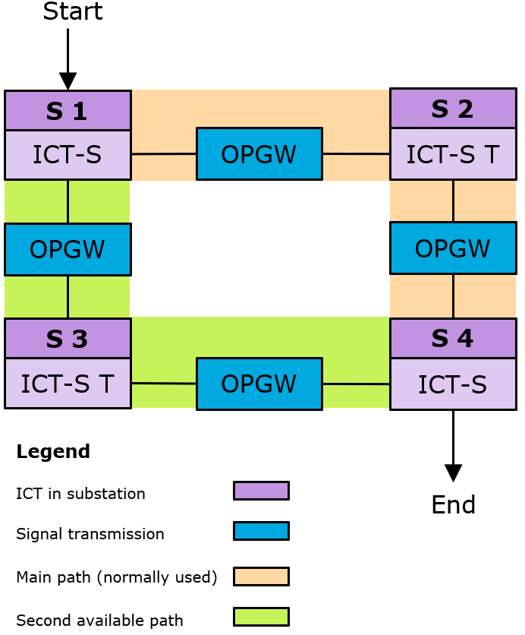
The route is defined as the complete path, including the ingress and egress points, the information and communication technology (ICT-S) in the transit function (T), and the OPGW function blocks for signal transmission.
Figure 2 Example communication grid with a main and second redundancy route between two substations

Boundary conditions
As already mentioned in the previous section, several boundary conditions apply to the analysis in this contribution:

Use of OSI Layer 3
The OSI layer model is a method of classifying different network and application protocols into seven layers according to their function. The protocols that enable dynamic routing in a CN are located on layer 3 and require the lower layers for their functionality. Conversely, static routing is constrained to layer 2 [15].

Handling ingress and egress point
The ingress and egress points of the route are defined as function blocks at which the communication connection enters and exits the network. As illustrated in Figure 2 the substations are S1 und S2. In this contribution, these points are assigned special reliability characteristics. In the event of a failure of the respective component, the service between these points would be immediately compromised. The present contribution places particular emphasis on dynamically managed routes. Consequently, the availability of the ingress and egress points is set $P_{Ingress}=P_{Egress}=100\%$ and this setting renders it moot for the result in the further availability calculations.

Numbers of possible routes available
Another important constraint is that there must always be another route between the ingress and egress points in the communication network. Dynamic routing can only select an alternative route if one exists. If this is not the case, the method for static routes according to [6] must be used for the reliability calculation.

Mathematical correlations
The mathematical relationships between the reliability parameters mean failure rate $H\left(\overline{Z}\right)$, mean duration of the failure state $T\left(\overline{Z}\right)$ and unavailability $P\left(\overline{Z}\right)$ are shown in (3) [13].
$$\begin{aligned}P\left(\overline{Z}\right)=H\left(\overline{Z}\right)⋅T\left(\overline{Z}\right) \#\left( SEQ num 3\right)\end{aligned}$$
Formulas (4) and (5) are used to calculate reliability data.
$$\begin{aligned}H\left({\overline{Z}}_{1}∨{\overline{Z}}_{2}\right)=H\left({\overline{Z}}_{1}\right)+H\left({\overline{Z}}_{2}\right)-H\left({\overline{Z}}_{1}∧{\overline{Z}}_{2}\right)\#\left( SEQ num 4\right)\end{aligned}$$
$$\begin{aligned}H\left({\overline{Z}}_{1}∧{\overline{Z}}_{2}\right)=H\left({\overline{Z}}_{1}\right)⋅P\left({\overline{Z}}_{2}\right)+P\left({\overline{Z}}_{1}\right)⋅H\left({\overline{Z}}_{2}\right)\#\left( SEQ num 5\right)\end{aligned}$$

Availability calculation of dynamic routes
This chapter calculates the impact of the significantly lower MTTR of dynamic CNs on AC. For the following comparison, the availability of the static route (orange) is calculated using (6).
$$\begin{aligned}P_{orange, static}\left(\overline{Z}\right)=P_{OPGW, 25km}\left(\overline{Z}\right)∨P_{ICT-S Transit}\left(\overline{Z}\right)=9,0261⋅{10}^{-4}\#\left( SEQ num 6\right)\end{aligned}$$

This results in an availability of:

$$\begin{aligned}P_{orange, static}\left(Z\right)=99,91\%\#\left( SEQ num 7\right)\end{aligned}$$

A new $T\left(\overline{Z}\right)=T_{LRT}$. is to be applied to the ICT-S Transit and OPGW components for the purpose of calculating the availability of the dynamic route. The value of $T_{LRT}$ this contingent upon the protocol employed by the CN. In this contribution the following applies: $T_{LRT}=\{t∣1s≤t≤120s, t∈Z\}$.
$$\begin{aligned}P_{orange, dynamic}\left(\overline{Z}\right)=H_{orange}\left(\overline{Z}\right)⋅T_{LRT}\left(\overline{Z}\right)\#\left( SEQ num 8\right)\end{aligned}$$
The results for different $t$ values are shown in the graph in Figure 3. From the results, we can deduce that this is a linear function, for which the following applies:
$$\begin{aligned}P\left(t\right)=mt+b\#\left( SEQ num 9\right)\end{aligned}$$
Since availability is expressed as a percentage, the following applies to $P\left(t\right)∈\left[0;100\right]$. The rate of the function can be determined using function (9). The values used for this are $P\left(t_{1}\right)=99,999996693 \%$ and $P\left(t_{2}\right)=99,999960312 \%$ with $t_{1}=10s$ and $t_{2}=120s$. This results in:

$$\begin{aligned}m=\frac{P\left(t_{2}\right)-P\left(t_{1}\right)}{t_{2}-t_{1}}=-3,301⋅{10}^{-7}\#\left( SEQ num 10\right)\end{aligned}$$

The y-axis intercept $b$ is calculated in (10):

$$\begin{aligned}b=P\left(t\right)-mt=100\#\left( SEQ num 11\right)\end{aligned}$$
The function of the graph for the dependence of the LRT on availability is as follows:
$$\begin{aligned}P\left(t\right)=-3,301⋅{10}^{-7}t+100\#\left( SEQ num 12\right)\end{aligned}$$

Figure 3 Link availability depending on several LRT values
The restoration of the connection is now accomplished at a significantly reduced time, which in turn leads to a significant increase in link availability. The maximum LRT contingent upon the AC, is delineated in Table 3. It is important to note that AC 2 is already fulfilled by the static route.
In order to fulfill the corresponding AC, certain rerouting times must be observed in this CN. By using $P\left(t\right)=P_{AC_{i}}$ with $i∈[1,5]$ and rearranging the function (12) to solve $t$, the results shown in Table 3 are obtained for the required rerouting time needed to fulfill the various AC. As shown by the result from (7), static routes in this CN already fulfill AC up to AC 2. If higher AC are required for a service, dynamic routing must be selected.
Table 3 LRT depending the AC
Availability class (AC) | $P_{AC}$ in % | Rerouting time t in h
AC 0 | < 99 | > 839,885
AC 1 | 99 | 839,885
AC 2 | 99,9 | 83,988
AC 3 | 99,99 | 8,399
AC 4 | 99,999 | 0,839
AC 5 | > 99,999 | < 0,839

Conclusion
In summary, it can be posited that dynamic routing significantly increases link availability. The results presented in Chapter 3 demonstrate that the pathways between the ingress and egress points attain the maximum AC, specifically AC 5. The advantages of dynamic routing are substantial. However, it is important to note that not all services can be transmitted via OSI Layer 3, because there are services that necessitate a consistent packet transit time. In the event of re-routing between the primary route and an alternative, there is the possibility that transit time will be subject to alteration. This, in turn, has the potential to result in malfunctions within the specific service. As demonstrated in Chapter 3 the calculation for the static route indicates that it is already in accordance with AC 2.
Moreover, it is imperative that the values are situated within the broader context. As stated in the introduction, the primary focus of this contribution is the examination of data connections in the context of the implementation of CCM. With regard to all components involved in the CCM process, the availability of the routes is at a very high level. It is evident that certain components of the sensor and actuator technology exhibit reduced availability values.
In order to comply with the availability requirements, set out in AC 3 and subsequent standards, it is imperative to recognize that the constraints do not stem from the connections between the ingress and egress points. Rather, the fundamental limitation arises from the ICT infrastructure present within the substations that facilitate these points. The mean time to repair (MTTR) of the ICT in these substations is $T\left(\overline{Z}\right)=4h$. In comparison with an LRT of $T_{LRT}\left(\overline{Z}\right)=30s$, the impact on overall availability is considerably higher, primarily due to the uncomplicated design of the ICT in the substations. Subsequent investigations should analyze the necessary redundancy of the ingress and egress points so that the availability classes, including the ingress and egress points, are met.
As mentioned in the introduction, the results of this contribution are needed for the successful implementation of CCM. They contribute to a more efficient utilization of the existing electrical grid, in which it can be temporarily utilized to a higher degree under certain conditions [16].
References

[1] | 50 Hertz Transmission GmbH, Amprion GmbH, TenneT TSO GmbH, TransnetBW GmbH, "Szenariorahmen zum Netzentwicklungsplan Strom 2037/2045, Version 2025," 2024.
[2] | Gesamtverbund InnoSys2030, "Innovationen in der Systemführung bis 2030," [Online]. Available: https://innosys2030.de. [Accessed 9 April 2025].
[3] | B. Musiol, C. Thöne and M. Zdrallek, "Algorithmically Creatable Reliability Block Diagrams for Special Protection Schemes According to the Single-Pass Model for Curative Congestion Management," in ETG Kongress, Kassel, 2025.
[4] | K. Kollenda and et al., "Curative measures identification in congestion management exploiting temporary ad-missible thermal loading of overhead lines," IET Generation, Transmission & Disttribution, vol. Volume 16, no. Issue 16, 2022.
[5] | B. Musiol, C. Thöne and M. Zdrallek, "Reliability Calculation for Curative Congestion Management in Transmission Grids with Optical Ground Wire Domi-nated Communication Networks," in IEEE PES ISGT Europe, Dubrovnik, 2024.
[6] | C. Thöne, B. Musiol and M. Zdrallek, "Modular Construction Kit for Calculating the Reliability of a Grid Operator's Communication Services," in International Conference on Probabilistic Methods Applied to Power Sysems (PMAPS), Auckland, New Zealand, 2024.
[7] | Bundesamt für Sicherheit in der Informationstechnik, Band G, Kapitel 2: Definitionen, 2013.
[8] | Huawei Technologies Co., Data Communications and Network Technologies, Beijing, China: Springer Singapore, 2022.
[9] | X. Jiang, M. Xu, Q. Li and L. Pan, "Improving IGP Convergence through Distributed OSPF in Scalable Router," in 11th IEEE International Conference on High Performance Computing and Communications, Seoul, Korea (South), 2009.
[10] | J. Papán and et al., "Fast ReRoute error detection - Implementation of BFD mechanism," in 17th International Conference on Emerging eLeraning Technologies and Applications, Starý Smokovec, Slovakia, 2019.
[11] | D. Katz and D. Ward, Bidirectional Forwarding Detection (BFD), RFC5880, Internet Engineering Task Force (IETF), 2010.
[12] | R. Billinton und R. N. Allan, Reliability Evaluation of Power Systems, New York: Springer Science+Business Media, 1996.
[13] | H.-D. Kochs, Zuverlässigkeit elektrotechnischer Anlagen, Berlin: Springer-Verlag, 1984.
[14] | K. F. Schäfer, Systemführung, Wiesbaden: Springer Vieweg, 2022.
[15] | International Standards Organisation, ISO 7489 - OSI Reference Model, Genf, 1984.
[16] | Consortium InnoSys 2030, "InnoSys2030 - Innovations in System Operation up to 2030 - Short Report on the Joint Project," Federal Ministry for Economic Affairs and Climate Action, 2022.
[17] | C. Thöne, B. Musiol and M. Zdrallek, "Reliability-Oriented Routing Metric for OSPF Protocol Applications," in ETG Kongress, Kassel, 2025.

