Integration of Photovoltaics into Microgrids for resilient Backup Power Supply of critical Infrastructure

Jakob Wieland1 | Nils Vierkötter1 | Maximilian Mütherig1 | Giuseppe Puleo1 | Markus Zdrallek1 |

**Correspondence**

Jakob Wieland

University of Wuppertal

Institute of Power Systems Engineering

Gaußstraße 20

42119 Wuppertal  
Email: [jwieland@uni-wuppertal.de](mailto:p.smith@uni-wuppertal.de)

1 University of Wuppertal, Wuppertal, Germany

**Abstract**

The increasing dependence on electricity supply, coupled with the growing risk of power outages pose electricity grid operators with enormous new challenges. To prepare for a potential blackout, strategies must be developed to ensure a partial supply of critical infrastructure and avert a national or international crisis. One approach is the establishment of microgrids that integrate photovoltaic systems during the grid restoration process. This study involved enhancing the smart grid laboratory at the University of Wuppertal to allow a realistic simulation of photovoltaic feed-in. The conducted tests demonstrated that photovoltaic systems can be successfully integrated into a microgrid without impairing grid stability. By implementing suitable control concepts, the volatile feed-in can effectively be utilized to relieve fuel-based power plants and extend the operation time of the microgrid. Furthermore, the photovoltaic feed-in enabled a temporary integration of additional critical infrastructure, whereby weather forecasting proved to be essential for optimal realization. A safe and efficient implementation of these strategies requires the development of emergency concepts in which the grid operators define both technical and organizational measures for a rapid resupply of the critical infrastructure.

**Keywords**

Microgrid, Photovoltaics, Blackout, Critical Infrastructure, Frequency Control, Smart Grid Laboratory, Grid Resilience

# Introduction

The increasing dependence of modern societies on a reliable electricity supply renders disruptions, such as large-scale blackouts, a significant threat to public safety and the functioning of critical infrastructure. Despite the high reliability of the German power system, various emerging risks—including climate-induced extreme weather events, cyberattacks, and changing load patterns due to electrification—highlight the need for resilient backup strategies [1].

Traditionally, the restoration of power supply after a blackout relies on black-start capable conventional power plants. However, their declining share in the energy mix necessitates the integration of decentralized energy resources. Photovoltaic (PV) systems, due to their wide availability and emission-free operation, represent a promising option for supporting microgrid-based restoration efforts. Yet, their fluctuating generation poses substantial challenges for system stability during microgrid operation [2, 3].

Within the scope of the research projects “SiSKIN” and “SiSKIN Applied” at the University of Wuppertal, strategies for the integration of PV systems into microgrids for the partial supply of critical infrastructure are being developed and evaluated [4]. A key component of this research is the Smart Grid Laboratory (SGL), which provides a realistic low-voltage test environment [5]. Here, black-start capable units are combined with synchronized PV systems to investigate their contribution to both grid stability and extended backup supply duration [6].

This paper presents control and regulation concepts for PV integration in microgrids. Two main strategies are addressed: (1) relieving conventional generation units by means of PV support to extend the operational duration [7], and (2) enabling the stepwise inclusion of additional critical infrastructure components through targeted PV integration [8]. Software-based implementation, real-time simulation, and experimental validation in the SGL form the methodological basis of the work. The results serve to inform the development of practical recommendations for distribution system operators and infrastructure managers aiming to enhance blackout resilience.

# Smart Grid Laboratory

To investigate innovative concepts for grid operation and control, a comprehensive and flexibly configurable low-voltage test grid was developed and implemented in the SGL. This test grid serves to experimentally validate novel operational strategies under realistic yet controlled conditions. It enables the representation of various grid topologies as well as the integration of variable load and generation profiles. The numerous installed measurement points allow for detailed monitoring of the grid state and thus facilitate precise evaluation of dynamic grid behaviour [9].

The SGL test grid, illustrated in Figure 1, comprises a total of 21 line segments and 16 nodes, 15 of which (K1 to K15) are equipped with measurement devices for continuous state monitoring. The total length of the observable lines is approximately 700 m. The grid topology can be flexibly reconfigured via nine installed load-break switches, enabling the implementation of radial, ring, and meshed grid structures. Potential disconnection points along the grid are indicated as dashed lines in the topological representation and allow for situation-dependent modifications of the grid structure [10].

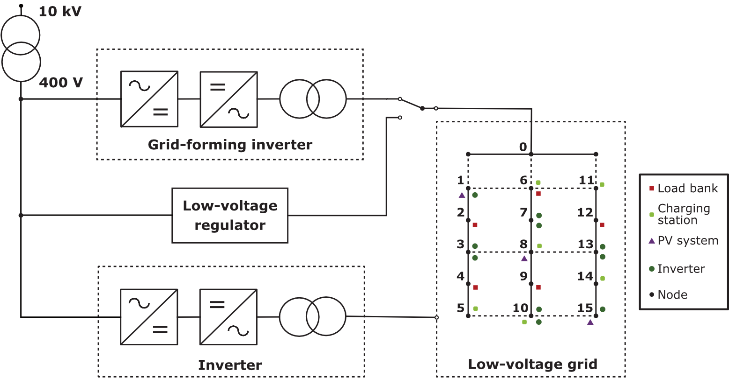Power is supplied to the test grid via the central input node (K0) and can be provided either through a voltage regulator or a grid-forming inverter. The voltage regulator has a maximum power rating of 250 kVA and allows targeted variation of voltage levels within the grid. Alternatively, the test grid can also be operated autonomously as a microgrid. For this purpose, a grid-forming unit is available, consisting of two synchronously operated bidirectional inverters and a downstream transformer. This architecture enables grid-forming operation in which frequency, voltage, and phase angle can be set independently. The grid-forming unit has a maximum power capacity of 150 kVA, with an output power of up to 100 kVA achievable at 400 V in low-voltage operation. In addition, static voltage and frequency control with adjustable characteristics is implemented [10].

Figure 1: Architecture of the Smart Grid Laboratory with connection options for operating equipment

With regard to an economically and technically viable implementation, a complete cabling of all equipment to every node was deliberately avoided. Instead, selected components – including load banks, a photovoltaic system, eight electric vehicle charging points with a maximum power of 22 kVA each, as well as ten pairs of bidirectionally operable frequency converters – were purposefully integrated into the grid. These components can be configured depending on their location and serve both generation and load simulation purposes [10].

Particularly noteworthy are the ten pairs of bidirectional frequency converters, which enable flexible adaptation to a wide range of operating scenarios. Owing to their capability to both supply power to the grid and draw power from it, they can be operated either as controllable sources or as dynamic loads. As such, they constitute key components for the investigation of control strategies, microgrid formation, and the dynamic integration of renewable energy sources [6, 10].

# Control Strategies for PV Integration

To stabilize and incrementally expand microgrids with integrated PV generation, two core concepts have been developed and tested: the droop control approach and the Breathing Grid Concept.

## Droop Control for Decentralized Grid Stabilization

The droop control concept represents an established method for decentralized frequency and voltage regulation in a microgrid without a central control unit [3]. Coordination of stable grid-forming and grid-supporting units is based exclusively on local measurements (frequency, voltage). Power provision is implemented via a 𝑃(𝑓) control scheme (Figure 2) with predefined droop characteristics [7, 11].

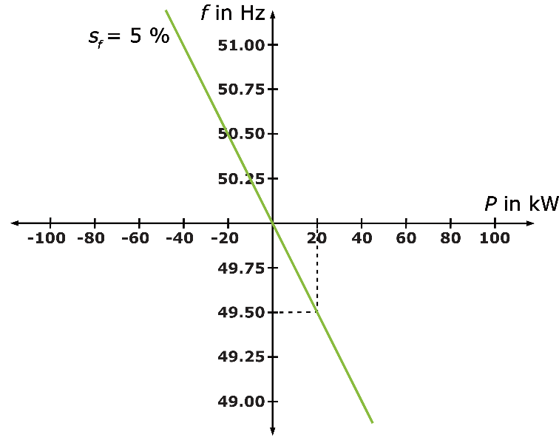Figure 2: Frequency-power relation (frequency droop of 5 %)

As part of the research activities, this concept was implemented in MATLAB using proportional controllers (P-controllers) [7, 11]. The P-controller responds proportionally to the deviation between the setpoint and actual frequency (or voltage), enabling straightforward integration of additional generators without communication infrastructure. The tuning of the proportional gain (𝐾ₚ) influences the control characteristics; a value of 𝐾ₚ = 50 was selected, corresponding to a droop setting of 2% [12].

## Breathing Grid Concept for Stepwise Grid Expansion

In addition, the so-called breathing grid concept was developed, which is based on the dynamic expansion or reduction of the microgrid [8]. The objective is the flexible integration of additional critical infrastructure components, depending on the currently available PV generation. In periods of sufficient PV output, the grid is expanded, whereas load-shedding strategies are applied in case of generation shortfalls. The decision to connect or disconnect additional loads is based on the active power capacity of the grid-forming unit and a defined reserve power, which accounts for the maximum feed-in power of the photovoltaic system weighted by a safety factor. Loads are only connected if the grid-forming unit’s power remains below a dynamically calculated connection threshold. Analogously, a disconnection threshold defines the point at which the load must be shed due to insufficient reserve capacity [8, 13].

# Experimental system and grid setup

Direct integration of the physical PV system into the distribution grid of the SGL was not feasible for the experimental setup. In order to enable reproducible and weather-independent testing, historical measured data of the PV system was modelled and integrates via the programmable inverters within the test environment. This approach ensured year-round availability of consistent PV feed-in profiles without dependency on actual irradiance conditions.

## Weather-independent integration of the PV system

The PV system has an installed nominal power *P*PV,n of 115.44 kWp, whereas the power converters of the SGL possess a nominal apparent power *P*UR,n of 9.7 kW each. For simulation purposes, the PV generation profiles were downscaled to match the power capacity of a single power converter, thereby allowing flexible configuration of the number of simultaneously used inverters in test scenarios. This method enables scalable emulation of varying PV feed-in within the distribution grid.

The set of historical PV feed-in data used in this study covers the months of December 2020 until August 2021. These datasets include a variety of seasonal and weather-related PV feed-in profiles, enabling a comprehensive assessment of the PV system’s impact under different conditions.

For the evaluation a representative feed-in profile recorded on a summer day in July 2021 was selected, shown in the following Figure 3. As described before, the original power values were downscaled to match the nominal rating of the inverter in the SGL. For visualization purposes, the active power is plotted with positive sign conventions, although the inverters internally receive the data with negative values to reflect feed-in behaviour.

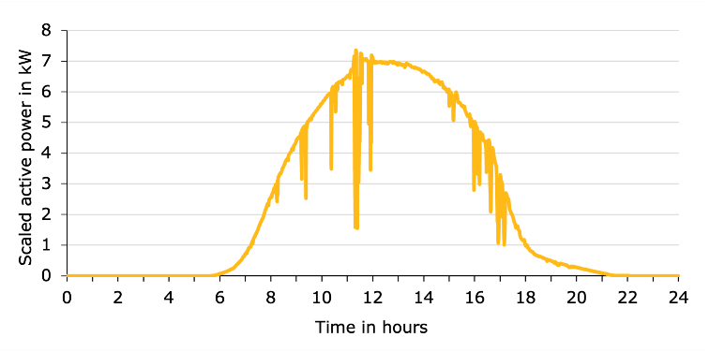

Figure 3: Historical PV feed-in data profile

As shown in Figure the selected profile exhibits a nearly ideal bell curve PV feed-in, characterized by a peak around midday and several distinct power drops throughout the day. The simulated feed-in spans approximately 15 hours, from around 6 a.m. to 9 p.m. This profile was deemed particularly suitable for testing, as it allows for both a clear observation of grid-former load reduction and an evaluation of the controller response to dynamic disturbances caused by the power drops.

The scaled feed-in data were continuously transmitted to two inverters via the SGL database, using a dedicated Python script. The active power profile represents a typical summer day in Germany and reaches a peak value of approximately 14 kW when both inverters are active. To accommodate a large number of test iterations while maintaining time-resolved dynamics, a simulation speed of one data point per second was chosen. Given that the historical values are recorded in one-minute intervals, this results in a time scaling factor of 1:60, effectively compressing the temporal evolution for experimental feasibility.

## Grid configuration

For the tests, the SGL was operated as a microgrid using the grid-forming converter system as the main power source. To maximize the representativeness of the grid dynamics, the longest possible topology was utilized. This configuration was achieved by closing the switches between nodes K0 and K1, K5 and K10, as well as K6 and K11 (Figure 1).

Within this setup, the inverters were not only used to emulate the PV feed-in but also configured to act as grid supporting generators in the droop control concept. Electrical loads were represented using the load banks, allowing dynamic adjustment of consumption during the tests.

The generation and consumption units were distributed across the available nodes to mirror a microgrid as realistic as possible. This distribution enabled the analysis of the interaction between generators and loads, providing a meaningful basis for evaluating frequency stability, control performance and dynamic system behaviour under decentralized operation.

# Implementation of control strategies in a microgrid

Before evaluating the integration of PV feed-in into decentralized control strategies, a preliminary validation of the droop control concept was conducted under microgrid conditions within the SGL. The aim was to verify the fundamental functionality of the implemented frequency and voltage control via proportional controllers, independent of the additional PV feed-in.

## Validation of the droop control

The droop control concept, as introduced in Section 2, enables decentralized regulation of active and reactive power through predefined droop characteristics. The grid-forming unit sets the systems voltage and frequency, while an additional grid-supporting unit adjust their power output proportionally to local deviations in these parameters. In the SGL setup, the droop coefficient for both voltage and frequency were initially set to 5 %.

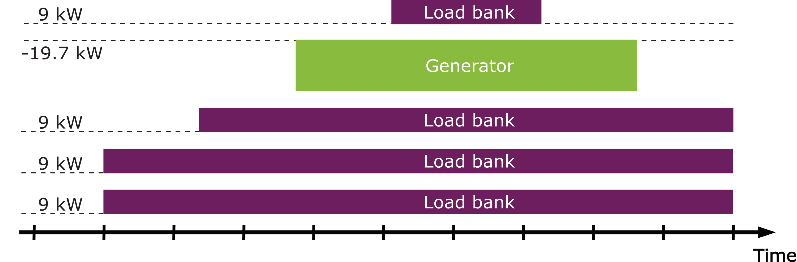

Figure 4: Test procedure for validating the control strategies

To validate the dynamic behaviour, a stepwise load increase initiated, beginning with the grid-former alone supplying the base load as shown in Figure 4. Two load banks of 9 kW each were switched in simultaneously, followed by a third 9 kW step after a short pause. At this stage, the grid-forming unit was solely responsible for a total of 27 kW active load. After approximately 120 seconds, two synchronized inverters were introduced as a combined additional generator with a nominal capacity of 19.7 kW. Their activation was followed by another 9 kW load increase, intended to analyse the response of the system under shared generation. Subsequently, this load was disconnected to observe the negative load step and finally the auxiliary generator was removed, returning full load responsibility to the grid forming unit.

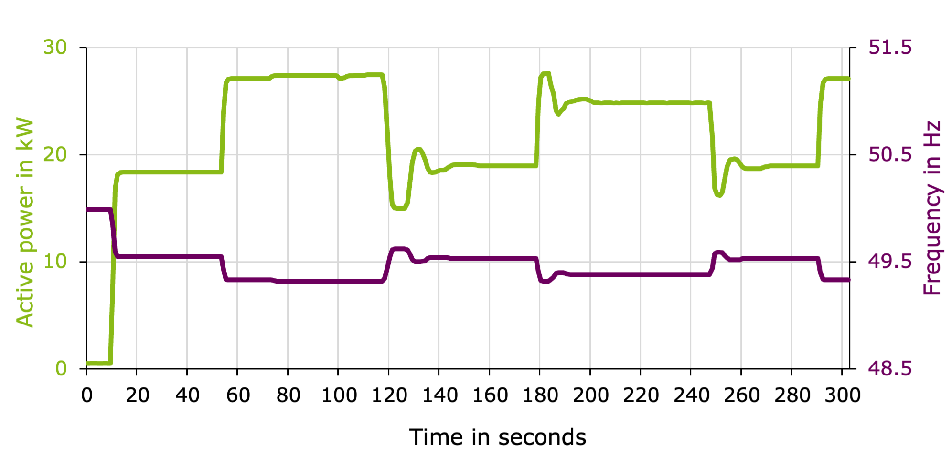

Figure 5: Validation of frequency behaviour in the droop control concept

The initial load steps led to a frequency drop of approximately 0.23 Hz per 9 kW, in line with the configured 5 % droop characteristic (Figure 5). Upon integration of the additional generator, a proportional relief of the grid former was observed. As expected from a P-controller behaviour, the inverter response showed transient oscillations in active power before settling around second 160, relieving the grid-former by approximately 8.5 kW. The system frequency stabilized at around 49.5 Hz. The subsequent 9 kW load addition was proportionally split between the generator and the grid-former, resulting in a frequency drop of only 0.15 Hz. These results confirmed the expected proportionality of the droop response and the stable power-sharing behaviour under load dynamics.

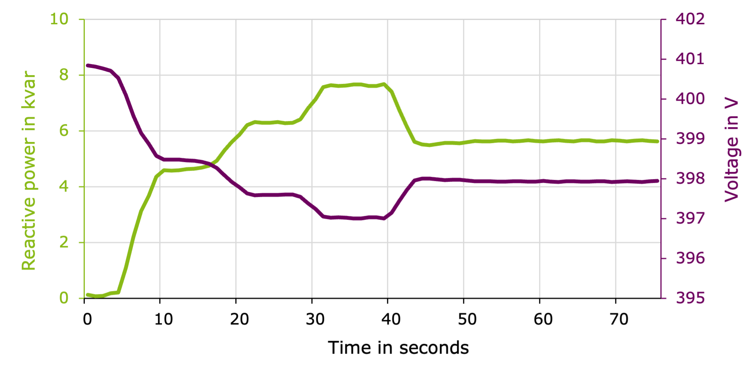

Figure 6: Validation of voltage behaviour in the droop control concept

In addition to frequency validation, a targeted reactive power feed-in test was conducted to verify the voltage regulation functionality (Figure 6). Six inverters operating at full apparent power (9.7 kW each) were used to inject a total of approximately 8 kvar into the system. The voltage droop setting was temporarily increased to 10 % to amplify the observable response. As a result of synchronizing the additional generator and enabling the P-controller at second 40, the reactive power contribution reduced the reactive load on the grid former by 2 kvar, resulting in a voltage increase from 397 V to 398 V. The observed steady-state deviation from the nominal voltage of 400 V was consistent with the expected behaviour of the P-controller.

Although voltage was not a primary focus in subsequent experiments, the validation confirmed that no instability or adverse effects were shown. The system maintained reliable voltage behaviour under reactive load conditions, allowing the remaining investigations to focus primarily on frequency dynamics.

## System behaviour under PV feed-in using droop control

In the next phase of the experiment the droop control concept was evaluated under the influence of dynamic PV feed-in. At the beginning of the test, the grid-former supplied a base load of approximately 27.5 kW to 28 kW, distributed across three 9 kW load banks. The same additional stable generator as before, formed by two synchronized inverters, was then integrated into the system to enable the proportional load sharing in accordance with the droop principle.

Following the synchronization of the additional generator, the historical PV feed-in profile (Figure 3) was fed into the microgrid via the inverters. The Figure 7 illustrates the distribution of active power among the grid-former, the PV inverters and the additional generator over time.

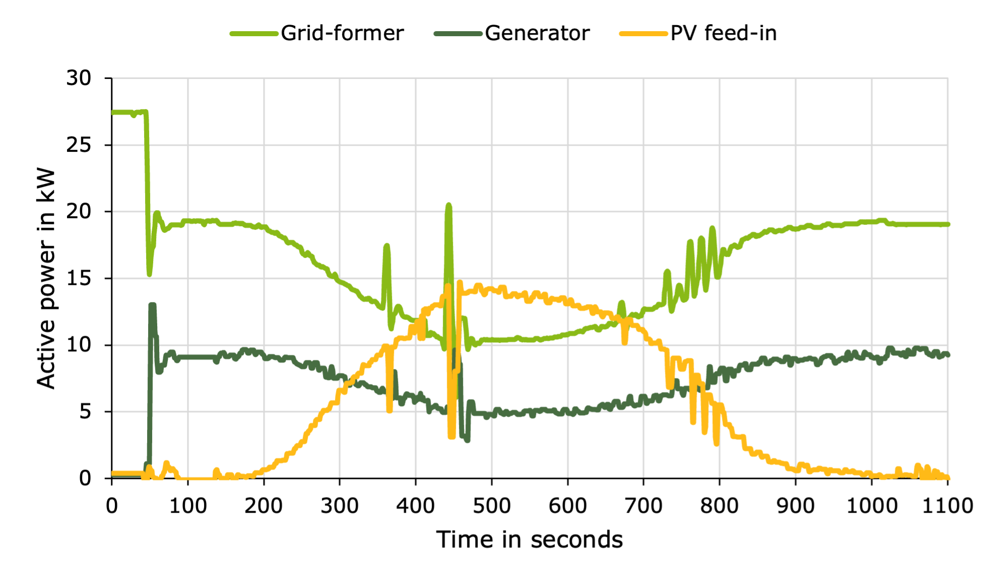

Figure 7 Active power distribution in the droop control concept on a summer day

The generator was synchronized at second 45, immediately reducing the grid-formers output by roughly 8.5 kW. As PV feed-in increased throughout the emulated day, the load on both controllable sources decreased. Between second 470 and 610, the grid-former provided less than 11 kW of active power while the additional generator reduced its output to around 5 kW. Power fluctuations caused by dips in PV feed-in were absorbed cooperatively by the two controllable sources.

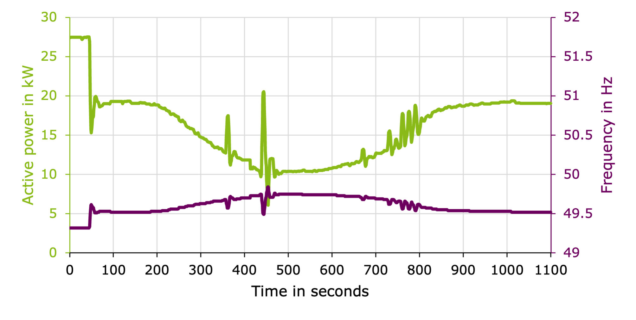

Figure 8: Droop control behaviour with PV feed-in over a full day

These transitions induced the expected oscillatory behaviour characteristic of the P-control concept. As seen in Figure 8, the frequency initially stabilized at around 49.3 Hz, corresponding to the high load under a 5 % droop setting. As the PV feed-in relieved the grid-former, the system frequency rose proportionally, reaching a maximum of approximately 49.7 Hz. Temporary drops in PV output – such as the drop around second 450 – led to minor frequency variations, yet the values remained within a narrow range between 49.5 Hz and 49.8 Hz.

## Adaptive load control concept

To further explore the dynamic integration of PV feed-in in microgrids, a control concept known as the “breathing grid” was implemented and tested. The strategy relies on adaptively increasing the load based on measured active power at the grid-former. Once a predefined relief threshold is maintained over a specified time window, an additional load is introduced into the microgrid.

The implementation was realized through a Python-based automation routine, which continuously monitored the grid-formers power output. The maximum allowable active power for the grid-former was set to 30 kW. To ensure a safety margin, a 10 % reserve of the maximum PV power – equivalent to 2 kW – was retained. The PV system was emulated by two inverters with a combined peak power of 19.4 kW, while the adaptive load step consisted of a single load bank rated at 4.5 kW.

From these parameters, a switching threshold of 23.5 kW was derived, representing the maximum allowable grid former load that would still permit additional load activation without exceeding its limit. A delay of 30 seconds of sustained relief (corresponding to 30 minutes in the original time scale) was expected before the load bank was added. The threshold for automatic load shedding was defined at 28 kW to protect the system from overload.

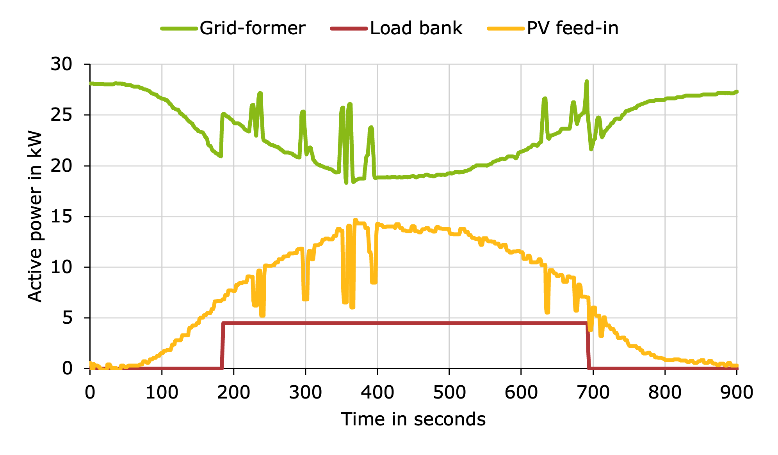

Figure 9: Active power of the grid-forming unit with a near-optimal PV feed-in profile and occasional power dips in the breathing grid concept

The control approach was tested using the same historical PV feed-in profile as before. Figure 9 illustrates the behaviour of the grid-formers active power and the corresponding response of the breathing control mechanism. Initially, the PV generation relieved the grid-former sufficiently to trigger the load integration, which then remained active for the majority of the simulation.

Despite several feed-in drops in the PV profile, only one brief event at the end of the emulated day caused an exceedance of the 28 kW limit. All other fluctuations induced by PV variability were effectively buffered by the grid-former without requiring a load-shedding response. Consequently, the integrated load remained connected for nearly the entire duration, demonstrating the feasibility of dynamic load allocation based on PV availability.

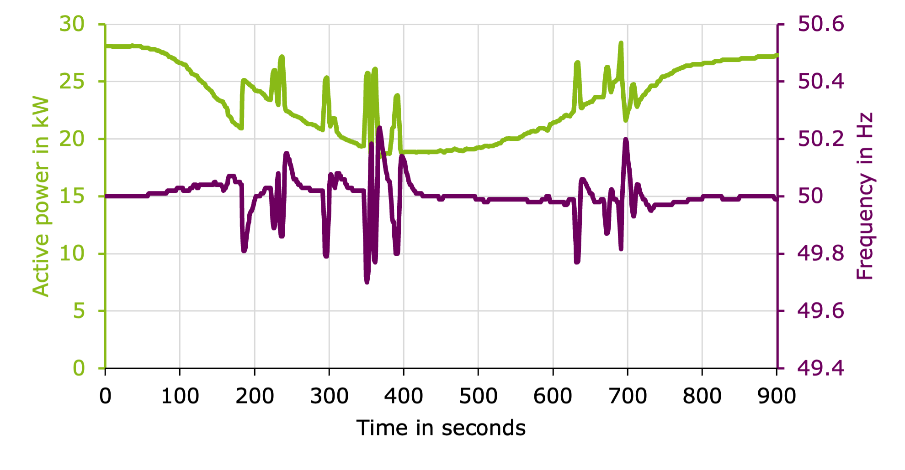

Figure 10: Frequency regulation behaviour under a near-optimal PV feed-in profile and occasional power dips in the breathing grid concept

The system frequency, shown in Figure 10, remained largely stable during the test. Short-term fluctuations induced by PV variability were consistently corrected by the frequency controller, which had been configured with a 10 % droop characteristic and an additional integral component to restore the nominal frequency. The maximum observed deviation reached approximately 50.2 Hz at second 370 but did not pose any risk to system stability.

Overall, the test demonstrated the practical viability of adaptive load scaling in response to renewable generation surplus. The breathing grid control allowed for the efficient utilization of excess PV energy while maintaining frequency stability throughout the test scenario.

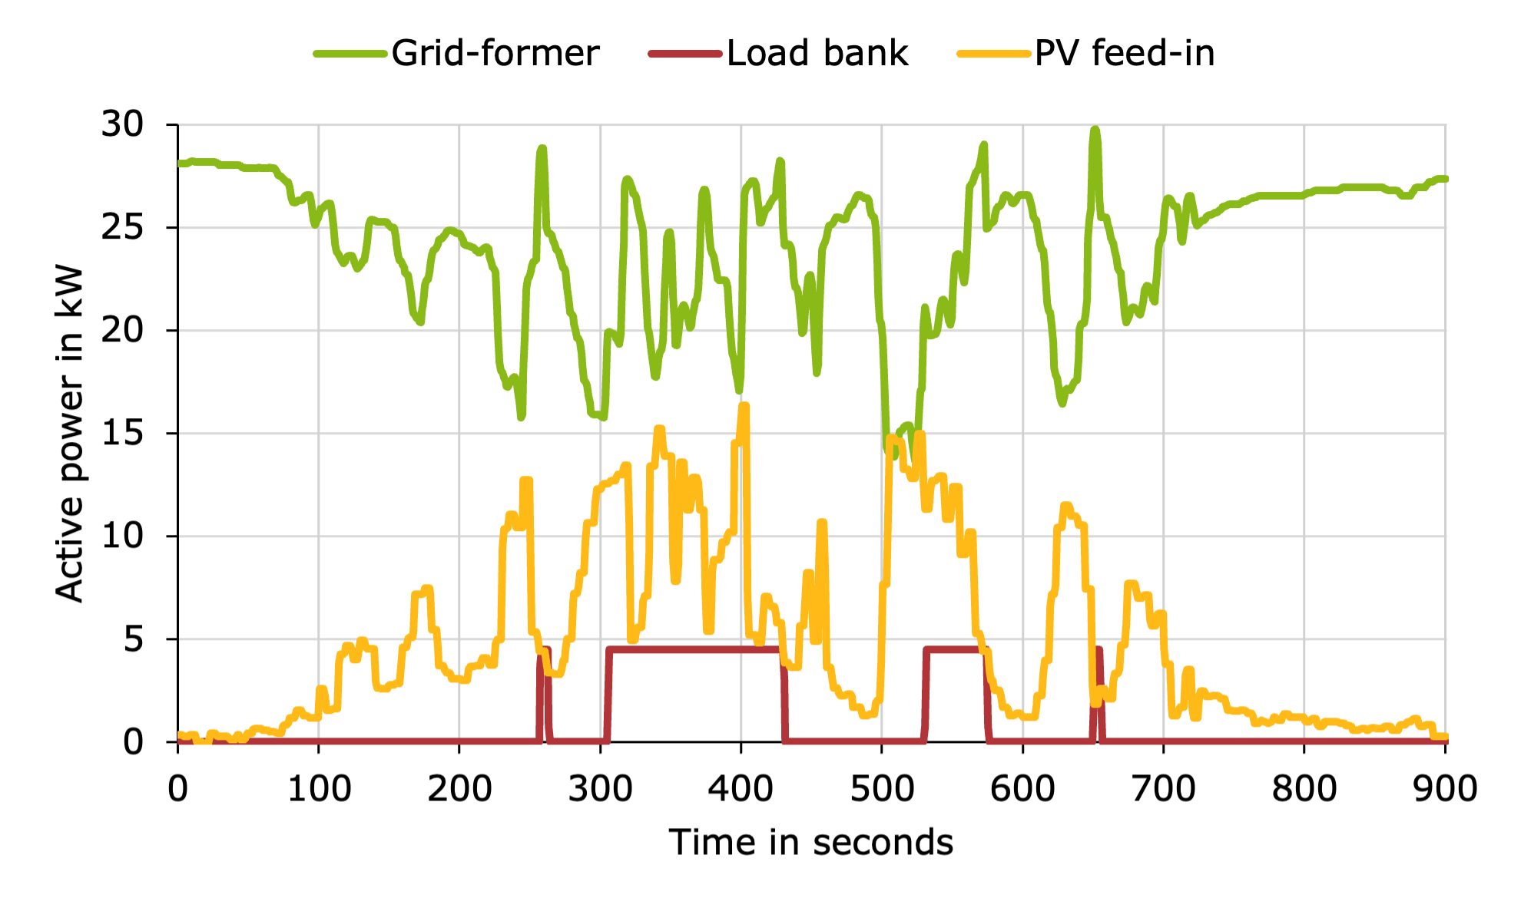

Figure 11: Breathing grid concept under a volatile PV feed-in profile

To evaluate the robustness of the breathing grid concept under less ideal conditions, a second test was conducted using a volatile PV generation profile measured on a summer day in June 2021 (Figure 11). This profile, unlike the previously tested bell-shaped curve, was characterized by frequent power fluctuations and a significantly lower peak output of only 8 kW. Throughout the 15-hour simulation window, no continuous hour was recorded without a major drop in PV power, resulting in a highly unstable generation pattern.

The adaptive load control concept was applied under these non-ideal conditions using the same setting as in the previous test. As a result, the load bank was successfully activated on four occasions throughout the simulation. Two of these activations – occurring early and late in the day – were short-lived, lasting only around five seconds before the relief threshold exceeded. The two remaining activations occurred during midday when the PV output temporarily stabilized, enabling a sustained contribution to the grid-formers relief. In total, the load bank remained active for just over three hours during the test.

A final variation of the test investigated the impact of a reduced activation delay. The delay time between threshold undershoot and load integration was shortened from 30 to 1 second, significantly increasing the systems reactivity. This adjustment resulted in ten distinct activation events of the load bank. However, due to the unchanged volatility of PV feed-in, many of these activations were short and followed by immediate disconnections, as the threshold was quickly exceeded again. Despite the increasing switching frequency, the total supply time of the additional load doubled to nearly six hours compared to the previous test.

# Conclusion and Outlook

The conducted tests successfully demonstrated the integration of PV feed-in into microgrids using programmable inverters within the SGL. The developed Python scripts enabled reliable transmission and application of PV data, providing a flexible framework for simulating variable feed-in profiles. This functionality forms the basis for future, more complex testing scenarios.

Within the scope of this work, two control strategies for microgrid operation with PV integration were investigated. The droop control concept proved effective in stabilizing the grid under fluctuating generation and load conditions. Throughout all tests, the system frequency remained within non-critical limits, confirming the reliable contributions of additional generators and PV feed-in to frequency stability. The adaptive load control approach based on surplus PV feed-in further demonstrated its potential to expand available supply capacities, particularly under favourable generation conditions.

The results revealed that a shorter delay in adaptive load integration allows for more efficient, albeit fragmented, utilization of available PV feed-in. At the same time, the tests highlighted the sensitivity of this approach to volatile feed-in patterns, emphasizing the need for careful parameter selection based on grid-specific conditions and weather assessments.

The results indicate that, under optimal irradiation conditions, the long-term integration of additional loads into the breathing microgrid can be facilitated by PV power. This is not the case under volatile feed-in conditions. In order to enable the integration of additional loads with only a single switching cycle per day, even in the presence of fluctuating PV generation, the use of a battery storage system is required. This aspect will be investigated in further simulations. Additionally, within the SiSKIN Applied project, the Smart Grid Laboratory will be extended by a battery storage system to enable further laboratory tests.

# Acknowledgement

The research project SiSKIN Applied is supported by the European Regional Development Fund North Rhine-Westphalia (EFRE.NRW).

9 References

1. Thomas Petermann; Harald Bradke; Arne Lüllmann; Maik Poetzsch; and Ulrich Riehm (2011) *Was bei einem Blackout geschieht: Folgen eines langandauernden und großflächigen Stromausfalls*, 2. Aufl, edition sigma, Berlin, Studien des Büros für Technikfolgen-Abschätzung beim Deutschen Bundestag, 33, ISBN 978-3-8360-8133-7.
2. Deutsche Energie-Agentur GmbH. II: *Integration erneuerbarer Energien in die deutsche Stromversorgung im Zeitraum 2015 – 2020 mit Ausblick 2025*. Netzstudie. Berlin, 2010.
3. Kerber, G. and Finkel, M. *Abschlussbericht zum Verbundvorhanden LINDA*. BMWK, 2019.
4. Mütherig, M. and Puleo, G. (2024) *SiSKIN*, [online] http://www.evt.uniwuppertal.de/de/forschung/forschungsgruppe-energiemaerkte-undflexibilitaetsmanagement/siskin/ (11.06.2024).
5. Lehrstuhl für Elektrische Energieversorgung: Smart Grid Lab, Bergische Universität Wuppertal [online], Online im Internet: https://www.evt.uni-wuppertal.de/de/forschung/smartgrid-lab/ (30.9.2024).
6. Puleo, G.; Mütherig, M. and Zdrallek, M. (2023) *Schutz kritischer Infrastrukturen während eines Blackouts*, Bundeszentrale für politische Bildung (Hrsg.),30.12.2023, No. 1-3/2024, p. 33–38.
7. Mütherig, M.; Puleo, G.; Zdrallek, M.; und Krause, W.(2024) *Konzepte für den Aufbau und Betrieb eines Inselnetzes auf Verteilnetzebene nach einem Blackout*, 18. Symposium Energieinnovation. Graz, 14.2.2024.
8. Puleo, G.; Mütherig, M.; Zdrallek, M. and Aschenbrenner, D. (2024) *Einbindung von Photovoltaik-Anlagen in Inselnetze auf Verteilnetzebene zur Unterstützung der Aufrechterhaltung kritischer Infrastrukturen während eines Blackouts*, 18. Symposium Energieinnovation. Graz, 14.2.2024.
9. Wazifehdust, M.; Tafuro, M. and Zdrallek, M. (2021) *Das Smart Grid Labor*, VDE INSIDE, No. 19, p. 18–19.
10. Koch, M.; Tafuro, M; Cano-Tirado, D; Forchheim, M.; Wazifehdust, M. and Zdrallek, M. (2023) *Low Voltage Laboratory Grid for Smart Grid Systems with Bidirectional Power Flows.* Kassel, ETG Kongress 2023.
11. Mütherig, M.; Puleo, G.; Krause, W. and Zdrallek, M. (2024) *Labarotatory Test to Validate Concepts to Build up and Operate a Microgrid at Distribution Grid Level after a Blackout.* Resilience of Electric Distribution Systems, Chicago.
12. Wellenreuther, G. And Zastrow, D. (2016) *Regler.* Wiesbaden, Springer Vieweg.
13. Mütherig, M.; Puleo, G.; Zdrallek, M. and Aschenbrenner, D. (2024) *Extensionof a low-voltage laboraotry grid by a grid-forming unit to perform microgrid studies.* Resilience of Electric Distribution Systems, Chicago.