Living Lab NRW as an Educational Resource for Building Performance Assessments
Isil Kalpkirmaz Rizaoglu1 [main author] | Karsten Voss1 [co-author]
Correspondence
Dr.-Ing Isil Kalpkirmaz Rizaoglu
University of Wuppertal
Chair of Building Physics and Technical Building Services
Pauluskirchstr. 7
42285 Wuppertal
E-mail: kalpkirmazrizao@uni-wuppertal.de

1 University of Wuppertal, Wuppertal, Germany

Abstract
As building performance simulation (BPS) becomes increasingly vital for sustainable building design in alignment with net zero carbon targets, its integration into architectural and engineering education still faces pedagogical challenges. The research presented in this paper aims to develop teaching materials that enhance building performance learning by combining BPS with in-site monitoring, testing, and measurements. It is based on the thesis that using real performance data from existing buildings, either as simulation inputs or as a reference point for benchmarking, can reduce the abstractness of simulation and strengthen the learning experience. The Living Lab NRW at the University of Wuppertal, which features eight experimental solar-powered houses and serves as a research, education, and public knowledge center for a sustainable built environment, provides a practical framework. The research follows five phases: (I) Planning and setting up monitoring systems, measurements, and tests, (II) data collection, (III) creation and calibration of BPS models, (IV) processing of data into educational content, and (V) implementation in teaching. This paper presents findings from the first three phases, focusing on thermal and daylight performance analysis. It contributes to the advancement of building performance education by offering original teaching materials and practical recommendations based on real-world data and experience.
Keywords
Sustainable Building Design, Building Performance Simulation (BPS), In-situ Monitoring and Measurement, Evidence-based and Experiential Learning.

Introduction
In today’s context, where global climate goals and the need for sustainable development in the built environment are becoming increasingly pressing, Building Performance Simulation (BPS) is gaining greater importance as a tool for developing designs aligned with these objectives. Particularly in light of the 2050 net zero carbon targets, simulation-based approaches have become a critical necessity not only for the design of new buildings but also for the high-performance retrofit of the existing building stock. These developments are accompanied by increasing environmental and regulatory pressures that demand performance-driven and adaptive design strategies within architecture, construction and engineering.
Accordingly, it is essential that future professionals acquire the skills to use these tools effectively during their higher education. However, the integration of BPS tools into educational settings continues to face significant challenges. Students having an insufficient background knowledge in building physics, which, combined with the abstract nature of building simulation, makes learning building simulation challenging, so reduces the overall effectiveness of the learning experience [1].
This study is based on the hypothesis that incorporating other building performance evaluation methods based on in-situ data, such as monitoring, testing, and measurement, into building simulation teaching can reduce the level of abstraction by enabling students to connect theory with practical experience, thereby improving the depth of learning [2]. The learning activities grounded in data collected from on-site measurements can support BPS studies by both enriching input datasets required for the creation simulation models and providing reference points for comparison studies between measurements and simulations.
The research, a partial progress and results of it presented in this paper aims to develop teaching materials that enhance building performance learning by combining BPS with in-situ monitoring, testing, and measurements. The research follows five phases: (I) Planning and setting up monitoring systems, measurements, and tests, (II) data collection, (III) creation and calibration of BPS models, (IV) processing of data into educational content, and (V) implementation in teaching. This paper presents findings from the first three phases, focusing on thermal and daylight performance analysis. It describes the collection of field data, the creation of BPS models, and their calibration.
The paper does not aim to provide an in-depth analysis of building performance outcomes. Instead, these results are included to illustrate the applied methods, to show the degree of calibration and validation by comparing simulation outputs with measured data, and to highlight their educational value.

Living Lab NRW and Experimental Houses
The research is situated at Living Lab NRW [3], a facility hosted by the University of Wuppertal for climate-neutral and sustainable buildings standing on the tree pillars of research, education, and public engagement. It enables long-term, real-life studies across five university sites, supporting both internal and external research initiatives. At the same time, it offers practice-oriented learning opportunities for students, trainees, and school groups through guided tours, lectures, and hands-on formats. As a public exhibition space, it also communicates sustainable building practices to a broader audience, fostering awareness and dialogue through events and open access to the demonstrator buildings.
Living Lab NRW consists of eight solar-powered experimental one-to two-story houses with up to 110 m2 of living space, which are designed and built in the scope of the Solar Decathlon Europe 21/22 [4,5] international student competition. Figure 1 presents a view of the Living Lab NRW campus, located near the Wuppertal city centre.
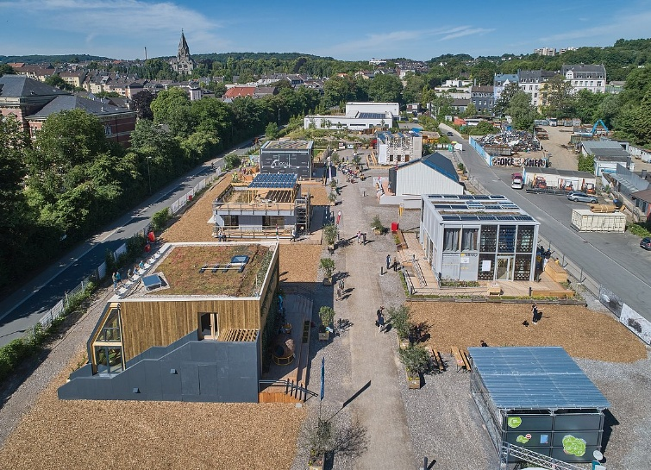
Figure 1 The Living Lab NRW Campus in Wuppertal, © SDE21/22, © Sigurd Steinprinz.
The detailed description of the experimental houses is provided by the SDE21/22 organizers and is available on the Building Competition & Living Lab Platform [6]. Also, SDE21/22 competition source cook [7] summarizes the competition, the results, the teams' contributions, and cross analyses of key topics.

Building Performance Assessments
Thermal and daylight performance are particularly interest of research due to their growing relevance and inherent tension in the context of climate change, particularly as rising temperatures make summer thermal comfort an increasingly urgent concern, often in conflict with goals for daylight availability.
Once the relevant performance areas have been identified, the required simulation inputs are defined, along with which data can be collected from the field and how. Depending on the type of data needed, suitable methods and equipment are selected. The simulation results, supported by field data, are then compared with actual measured performance, and the models are calibrated accordingly. Figure 2 illustrates the workflow of in-situ data collection, BPS model creation, and calibration.
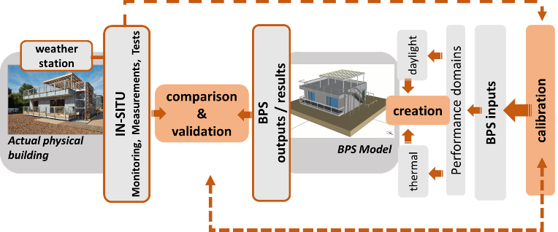
Figure 2 Illustration of the workflows between actual physical buildings as a case study and the models of Building Performance sSimulation (BPS): Creation of models, comparison of the results of the in-situ and simulation assessment and comparison of them in order to validation and calibration of BPS models.

In-situ data collection: Monitoring, testing and parameter investigations
Monitoring, in its most basic dictionary definition, refers to the systematic observation, test and measurement of a situation over time to detect changes. In the scope of this study, monitoring refers to the collection of data on building performance parameters such as temperature, humidity, energy use and indoor air quality using sensors or measuring instruments. For monitoring the indoor climate, all the houses are equipped with tripods fitted with indoor climate measurement equipment (i.e., air temperature, relative humidity, and CO2). The number of tripods in each house varies between 2 and 3, depending on the volume of the house and the use and volume of the rooms. All houses have their own energy monitoring panels including meters measuring the energy production and use, detailed for household equipment, lighting, heating, ventilation and air conditioning, domestic hot water.
Outdoor weather conditions such as air temperature, relative humidity, wind speed and direction, and solar radiation are monitored and recorded at the air station on the roof terrace of the house. These data are supported by diffuse solar radiation measurements taken at the university campus in the city centre.
In addition, some houses are equipped with additional sensors for further monitoring, such as the Prague (CTU) House, also surface temperature and heat flux sensors in between the exterior wall layers, and on the interior surface of window glazing which are used not only for collection of data directly to be compared to simulation results but also for calculation of some of the building thermal properties, i.e., the thermal transmittance (U-value) and heat transfer coefficients.
Besides the regular monitoring, some performance tests are repeated to assess potential performance changes over time. An example is the airtightness, it is a crucial factor for both durability and reduced heating energy demand, particularly in the case of the Living Lab houses, which were constructed using timber with a high degree of prefabrication. The initial airtightness measurements were carried out in 2022 as part of the competition using the blower door test method and in 2025, selected buildings are retested to evaluate any changes resulting from occupancy [8]. Although the houses that initially performed well continued to demonstrate adequate airtightness, these measurements provided valuable input for the development of reliable BPS models.
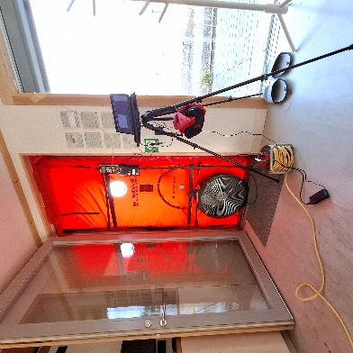
Figure 3 Air tightness assessment via” blower-door test” (right) and comparison of the results from different years (left).
Beyond regular procedures, specific tests and measurements are carried out according to the requirements of the performance aspect under investigation, such as co-heating tests in thermal performance studies or illuminance measurements and daylight factor calculations conducted on site in daylight-related research.
Parameter investigations are an integral part of the research, aiming to better understand how a system behaves under varying conditions. Specific parameters with the houses and/ or within their simulation models are systematically modified to examine their influence on the outcomes, highlighting the sensitivity of the system to each parameter and the magnitude of its impact. For example, some parameters such as solar gains, natural and mechanical ventilation, shading elements are particularly investigated for the thermal and daylight performance.
An illustrative example can be the investigation the effect of solar gains. The comparison of the indoor temperatures in free floating mode in the periods of sunny and cloudy wintertime (Fig. 4) clearly demonstrates the effect in relation to the ratio of the transparent openings (e.g. window) and structural shading typology on different facades, which are summarized in Table 1. Such a simple parameter comparisons are not only valuable as input for simulations but also serve as a basis for informing future parameter studies through simulation.
(a)
(b)
Figure 4 Measured indoor air temperatures for the controlled free-floating test in Living Lab NRW Houses with outdoor air temperatures (Tout) and global radiation: (a) sunny free-floating and (b) cloudy shaded free-floating in the 2024 -2025 winter season. The abbreviations refer to the Living Lab NRW houses. "Pre-conditioning" refers to the period during which a building is heated until a stable indoor air temperature is reached, ensuring uniform initial conditions for reliable comparison. “Controlled free-floating” mode in a winter season refers to sharply lowering the heating setpoint of a space e.g. from 30°C to 5°C degrees, thereby letting the space indoor temperature float free, but also controlling the point of minimum temperature.
Table 1 Living Lab NRW Houses’ structural shading typology and window-to-floor area ratios. The abbreviations refer to the Living Lab NRW houses.
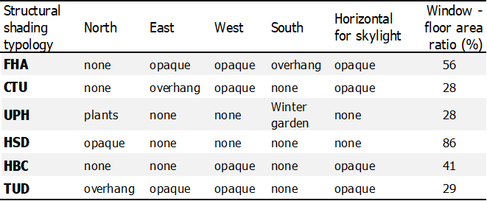

Building Performance Simulation Models
Beginning with this section of the paper, the focus shifts to one of the houses for a detailed examination of the BPS modeling, on-site measurements, and their comparison. The CTU House, is one of eight experimental houses in Livng Lab NRW, built by the FIRSTLIFE team from the Czech Technical University (CTU) as part of the Solar Decathlon 2021/2022 competition. This passive house with a prefabricated wooden structure has floor plan dimensions of 8.4m by 10.8 m and 66 m2 net floor area consisting of a student room with a kitchenette and bathroom, a community room and a corridor.

Thermal Model
WUFI® Plus [9] is chosen for being a multi-zone dynamic thermal simulation tool with high control over inputs and high-resolution results. A key reason in selecting this simulation tool is its ability to incorporate field data as inputs, such as measured weather conditions and user-defined schedules (e.g., occupancy, shading operations), on an hourly basis across the 8,760 hours of the year. Due to the educational context the tool is applied for single zone modelling only.
The assessments include two heating seasons of 2023-2024 and 2024-2025 and also the summer season of 2025. The set-up of simulation models is varying based on the season. The partial results only from 2023-2024 winter are tackled as a representative illustration of the methods implemented. Internal gains are calculated based on data collected via energy monitoring system. For tests that include active heating, fan heaters are used in order to exclude any consideration regarding the houses’ Heating Ventilation and Air Conditioning (HVAC) systems, which vary largely. The key settings for thermal modelling are illustrated in Table 2. The values are derived partly from the team's as-built drawings and reports [6], and partly from on-site measurements, testing, and calculations [10].
Table 2 Key settings for thermal model from 2023-2024 winter
Conditioning | : | Electric fan heater with a constant output of 3 kW and an airflow rate of 250 m³/h
Internal gains | : | Appliances in a standby mode (convective heat input approx. 256 W)
Occupancy | : | No
Passive ventilation | : | No (extra measures taken by covering the ventilation openings)
infiltration | : | n50 0,90 1/h, n50, by conducted blower-door tests described in DIN EN 13829.
Blinds/curtains | : | Without (Open)
Mechanical ventilation | : | On (with 125m³/h airflow rate and 82% heat recovery - only for fresh air)

Daylight Model
Climate Studio [11], a plug-in for the architectural modeling software Rhinoceros 3D [12], was selected as the daylight simulation tool due to its advanced capabilities, including precise input control and high-resolution output. The building’s interior and façade elements were modeled with a maximum deviation of 2 cm. Sensor height was set at 0.9 meters above the floor, with an initial spacing of 1.2 meters, later reduced to as low as 0.1 meters to enhance spatial resolution. The key settings for the daylight model are presented in Table 3.
Table 3 Key settings for daylight model
Sky model | CIE Overcast Sky Model for Daylight Factor
Architectural Model | All space and facade details are modeled within  2 cm tolerance: wall thickness, frames, mullions, interior partitions, ceilings and furniture.
Sensor height from floor [m] | 0.9
Sensor spacing  (distance between) [m] | Base case 1.2 (later the resolution is increased)
Average target and limit values for daylighting evaluations metric, DF [13,14] | Target DF 2 % & minimum DF=0.7 %;

3.3. Comparison, Validation and Calibration
Calibration is the process of adjusting model inputs so that the outputs better reflect real-world conditions. It is essential for improving the accuracy of building performance simulations by reducing discrepancies between predicted and actual outcomes. The trial-and-error method is a simple approach where parameters are manually adjusted to match measured data. While it can sometimes be time-consuming, it is easy to apply and sufficiently efficient and precise for educational purposes.

Thermal Performance
Indoor air temperature is chosen as a reference variable for evaluating thermal performance between simulations and in-situ assessments. To calibrate the BPS models, simulation results are repeatedly compared with field measurements of indoor air temperature using both design-based and in-situ input values (Fig. 5). The level of correspondence between the simulation results and the in-situ measurements is noteworthy.
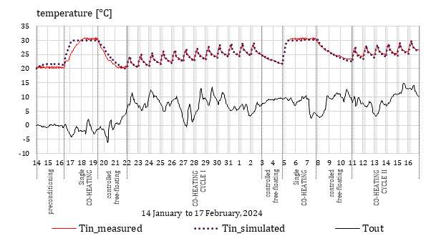
Figure 5 Comparison of the measured and simulated hourly mean indoor air temperatures (Tin) of the CTU house with the outdoor air temperature (Tout) in the 2023-2024 winter season. The time slots highlighted in grey represent the operation of the fan heaters for night heating cycle of 6 hours, and the periods defined with dashed vertical lines refers to a specific test, e.g. starting with preconditioning. Note: (1) The discrepancy between the measured and simulated data on January 17 is due to an error in the control setting of the heater; and (2) The lack of measurement data on February 5 is due to failure of the data logger of the monitoring system.
As mentioned earlier, certain investigations require specific tests and methods. For thermal performance assessment, the co-heating test is applied. This test is defined as an assessment of the as-built performance of a building by comparing the heat input into the building against the temperature disparity between the inside and outside of it, which is to be minimum 10°K [15]. During a co-heating test, the houses are uniformly heated to a steady-state elevated temperature (e.g., 30 °C) using electric fan heaters. Earlier studies on dynamic test methods for buildings, in particular those from Annex 71 [16] in the IEA EBC program are used as a reference for this in-situ test.

Daylight Performance
Daylight factor (DF), which is the ratio of internal horizontal illuminance at a point within a building to the exterior horizontal illuminance under an overcast sky, is chosen as the metric for daylight availability assessment; for allowing comparison regardless of dynamic sky conditions. As reflectance and transmittance are key inputs for daylight simulation, in-situ data collection is carried out accordingly. A calibrated digital lux meter [17] was used to measure illuminance (E) [lux] and, with a custom measurement tube, specific luminance (L) [cd/m²] values.
Comparable to thermal modelling, daylight models are continuously compared to measurements by adjusting the key inputs. Final level of the calibrated model by comparison results are presented in Figure 6.
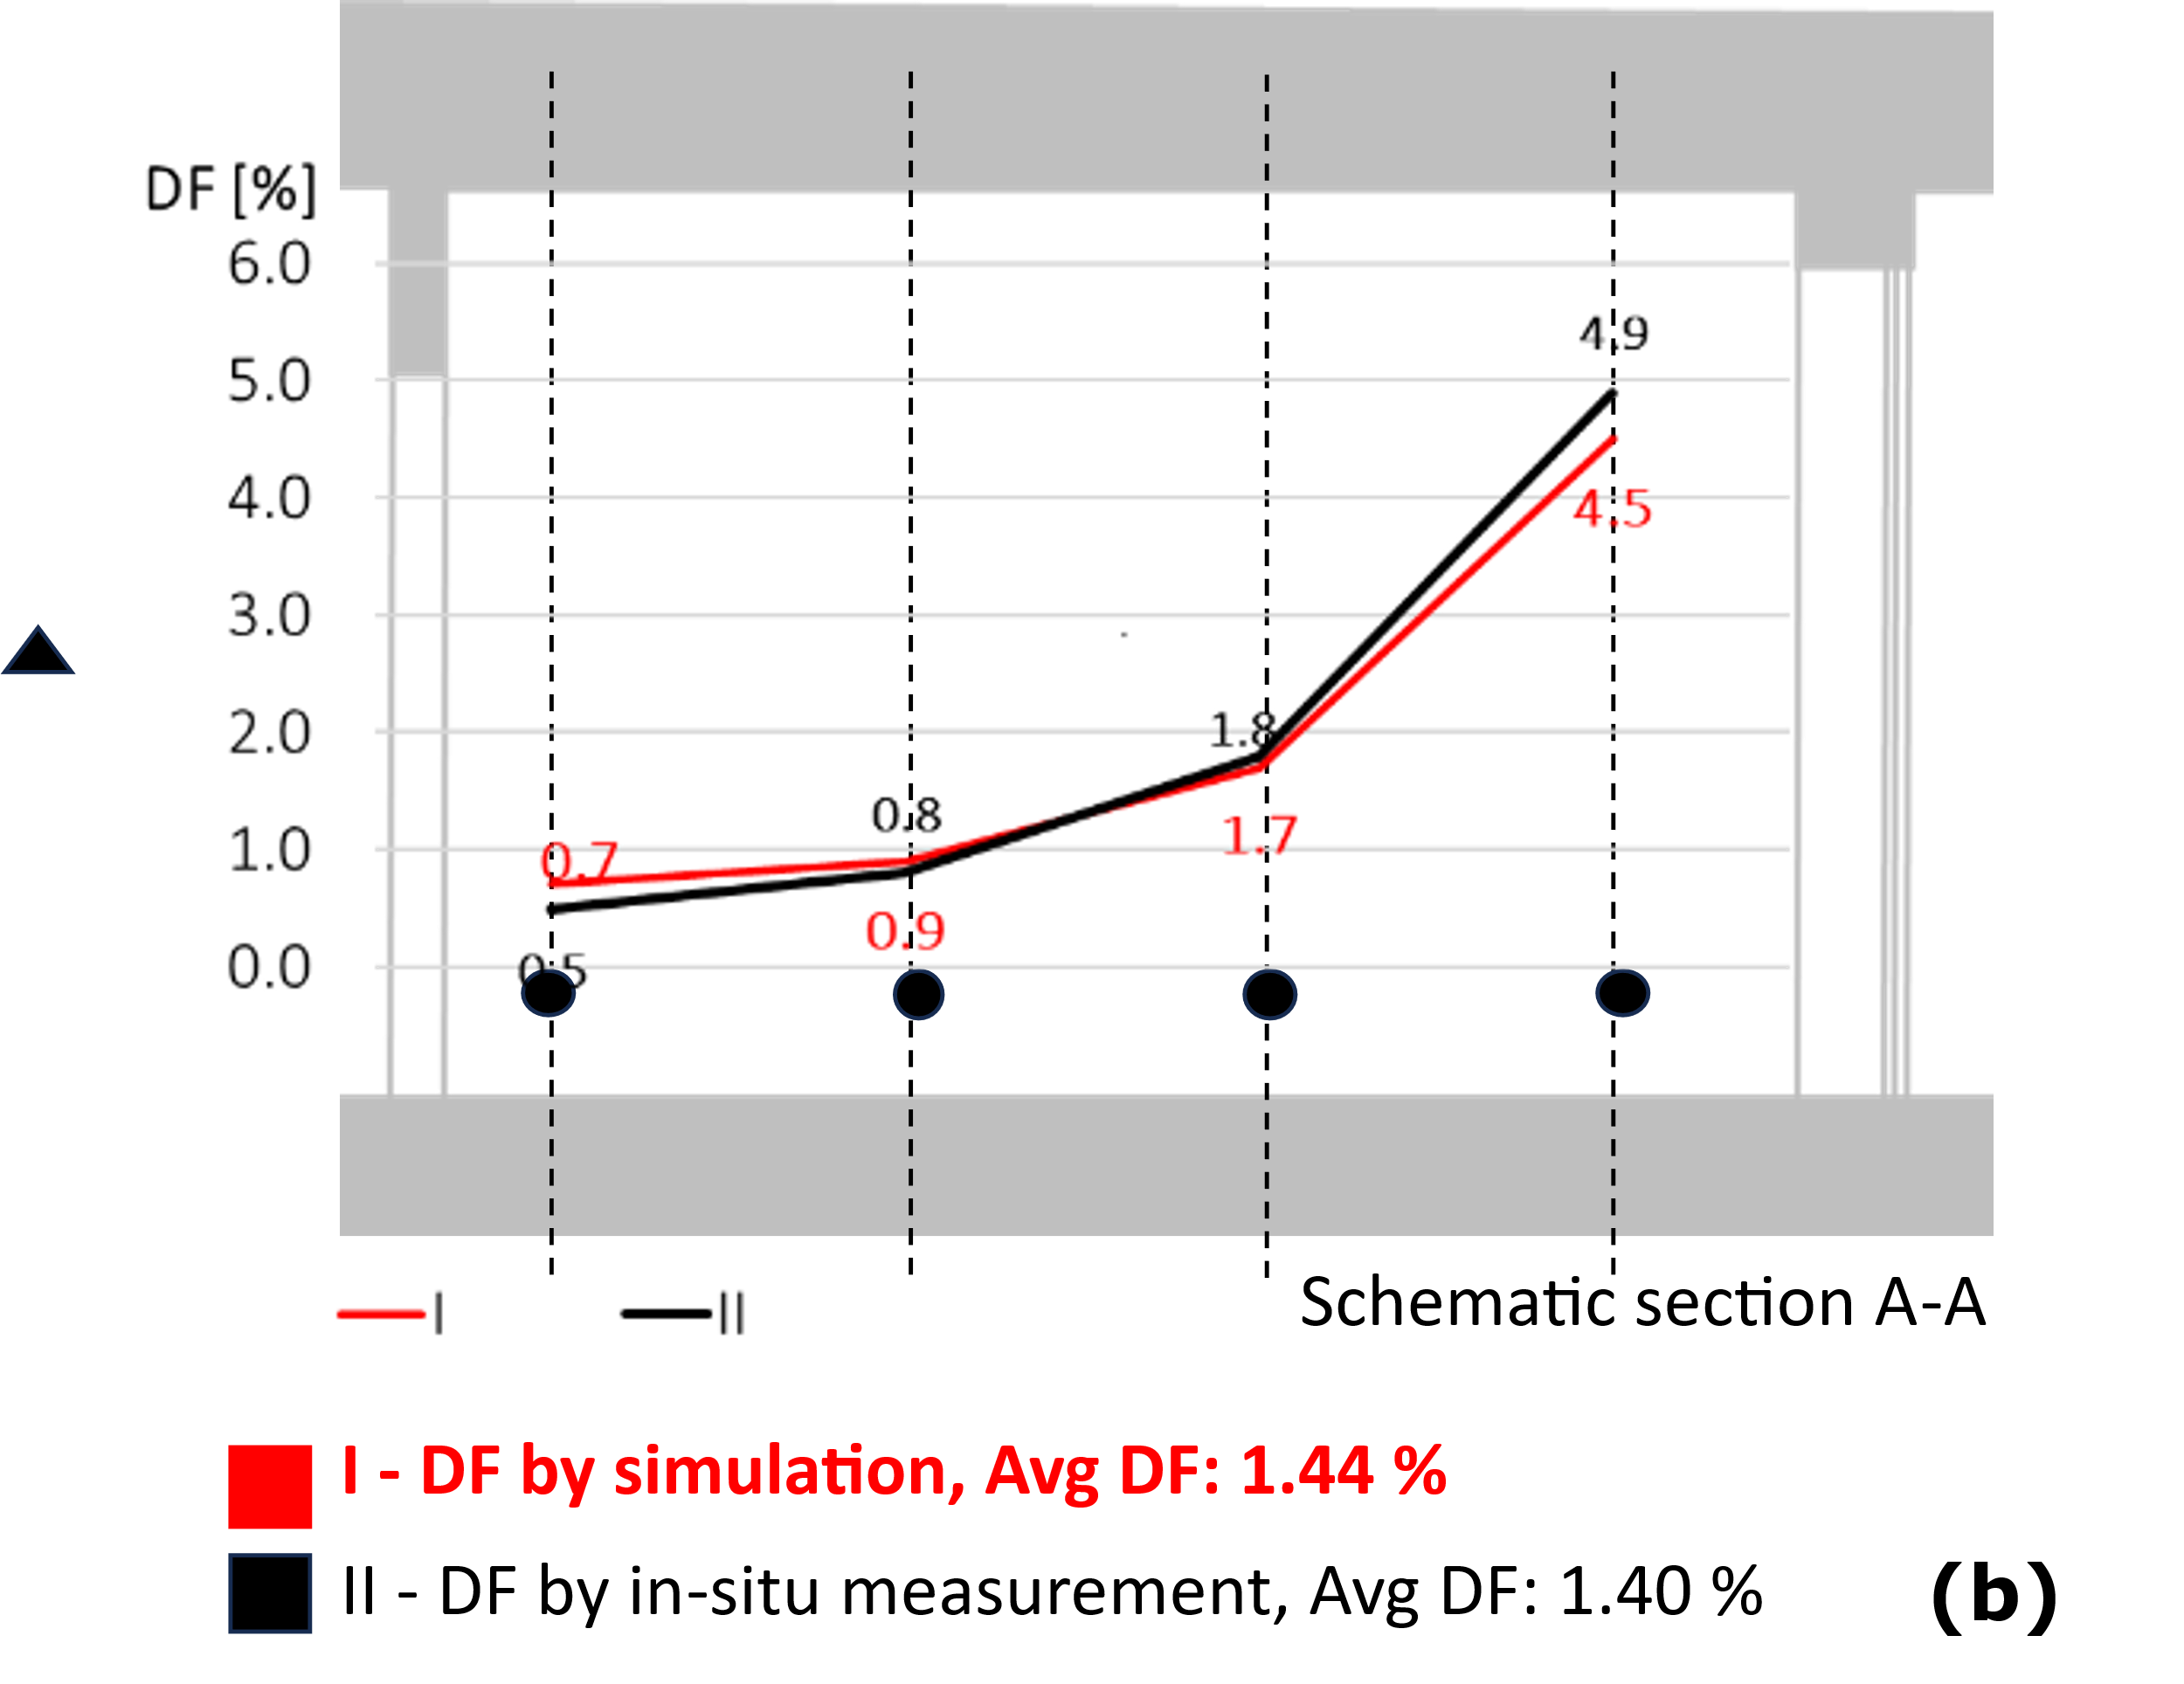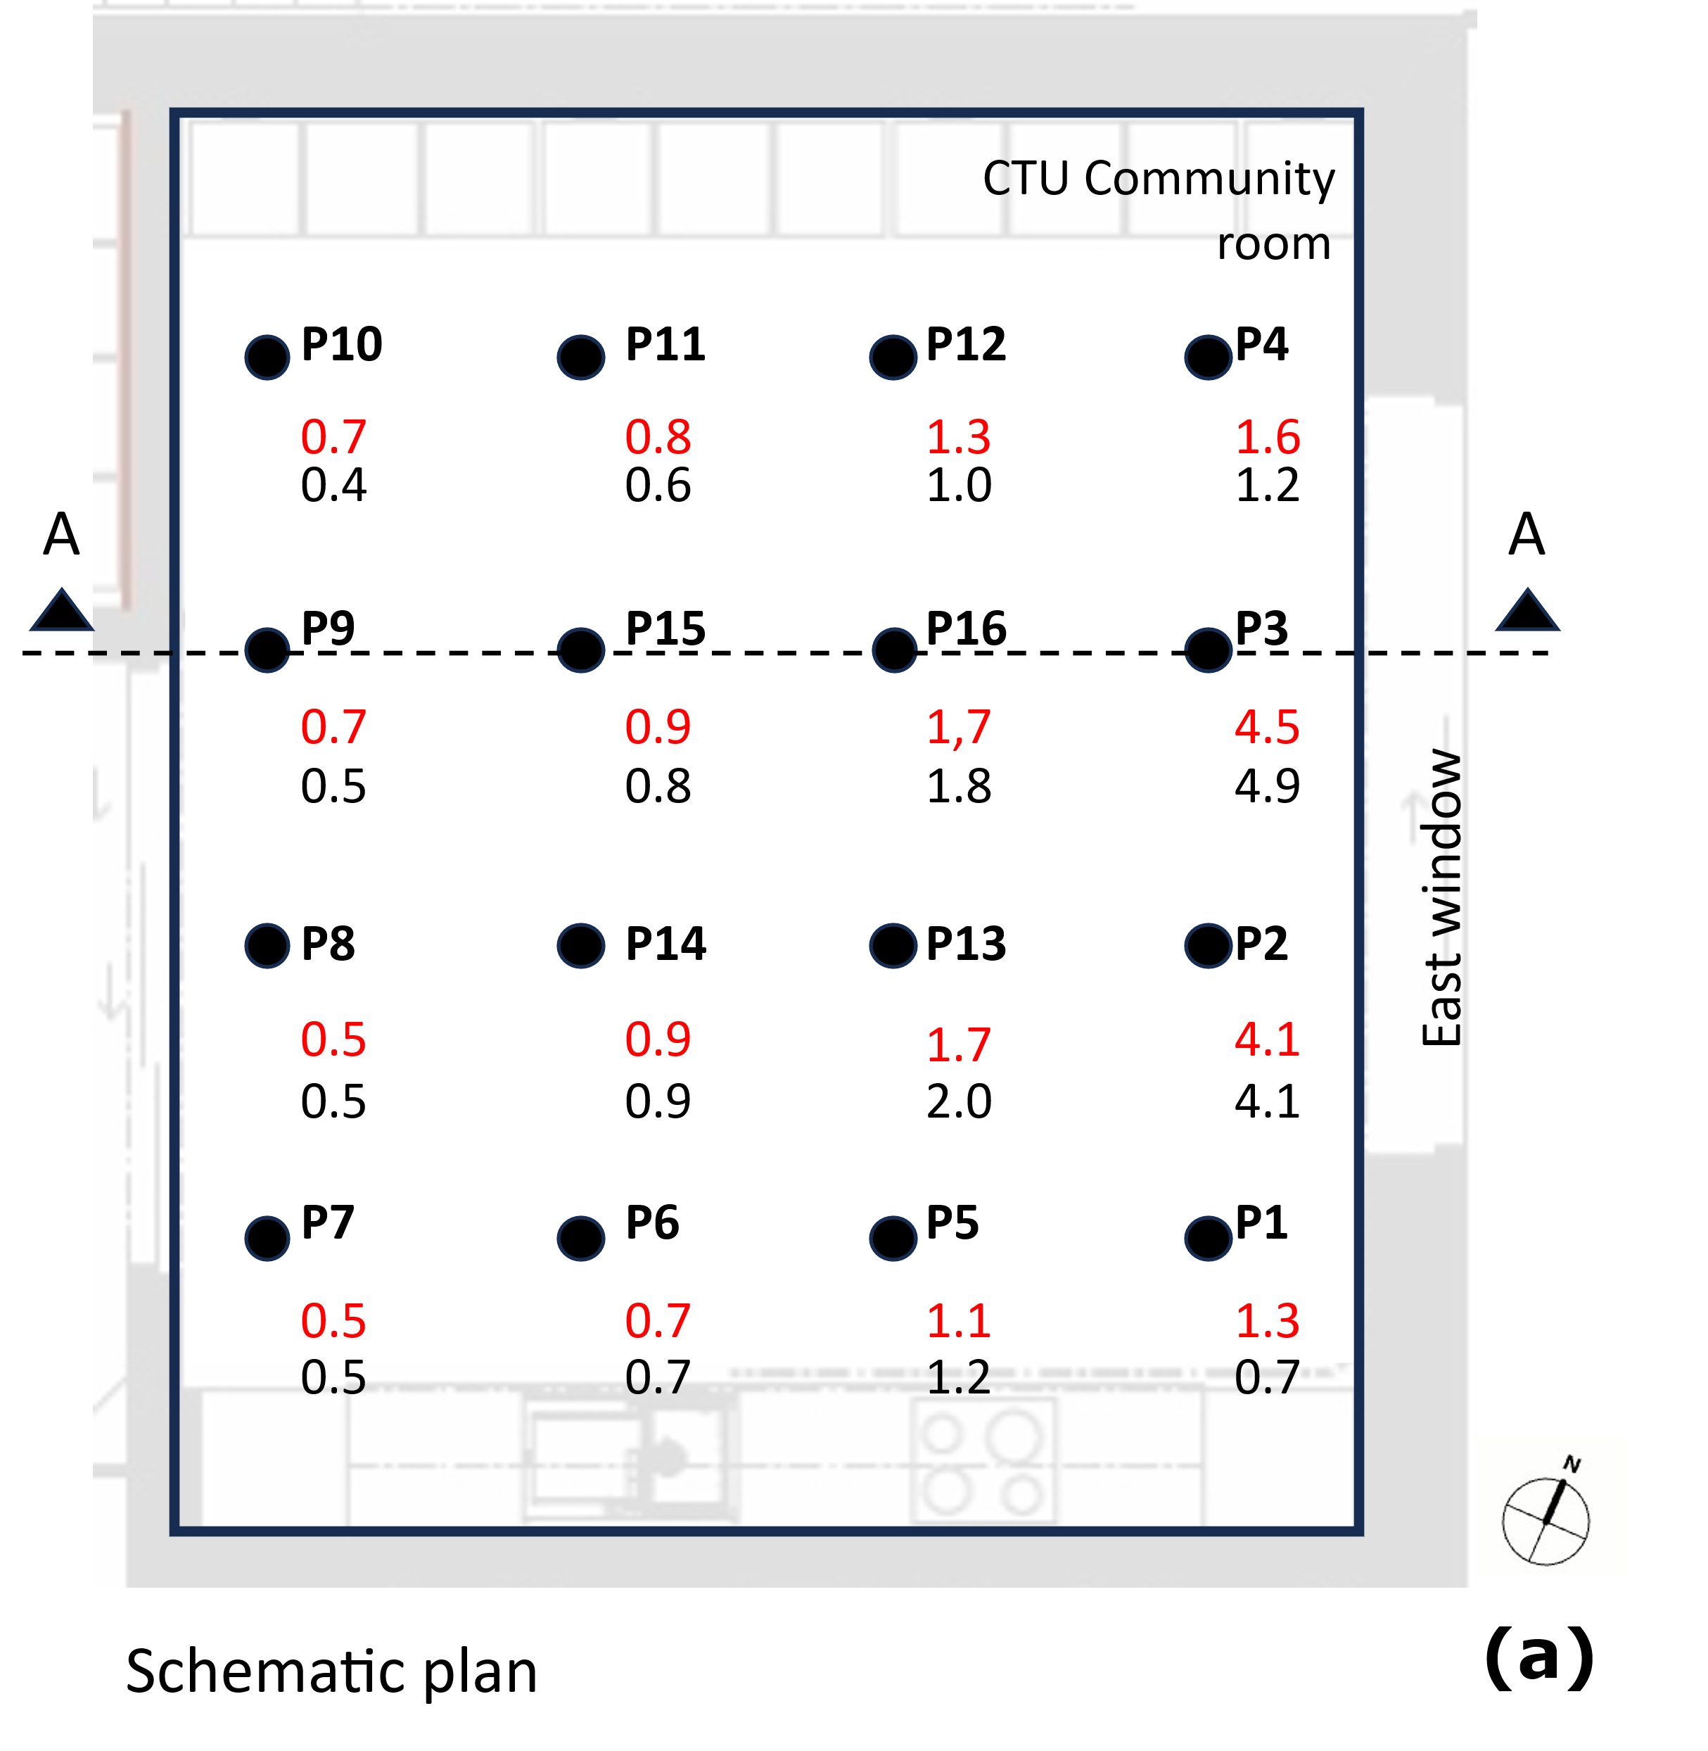
Figure 6 Comparison of daylight availability in a room of the CTU House: (I) DF by simulation and (II) DF by in-situ measurements: (a) DF values on a schematic plan and (b) Variation of these values on a schematic cross-section as approaching the window.
It should be noted that evaluating whether the case study meets daylight performance criteria is beyond the scope of this study and is addressed in a separate publication [18]; therefore, no target DF value is provided here.

Discussion and Conclusion
This study presents an integrated approach to developing teaching materials for integrated building performance education by incorporating in-situ data into BPS along with the partial results. The creation of a detailed description of the construction and BPS models that are calibrated based on in-situ tests and measurements are achieved in the scope of this research.
The goal is to support more effective learning in building performance assessment, especially in the context of BPS teaching at the university level. This methodological structure can serve as an example for those wishing to undertake similar work. Therefore, the study does not provide performance assessments; measurements and simulations were presented solely to demonstrate the design process of the teaching materials and methodology.
In the next phase, these materials will be presented to students and tested in seminar and studio courses. Students will access the simulation models and measurement data, reproduce the simulations using the provided information, and compare their results with the in-situ measurements. Since each step in the process has already been checked and adjusted (calibrated and validated), any discrepancies in student results will be attributable solely to user-related factors, such as data entry errors, misinterpretations, or incorrect evaluations, which can be easily identified and corrected. Going a step further, once students have successfully recreated the baseline, they can use the models for parameter studies, evaluating design alternatives, identifying potential improvements, and optimizing building performance.
These educational materials are designed to equip students with the skills to apply different methods in an integrated way in performance assessments, to understand the strengths and limitations of these methods, and to critically interpret their results.
Acknowledgement
The research is carried out in the framework of the project “Living Lab NRW”, supported by the Ministry for Economic Affairs, Industry, Climate Action and Energy of NRW under the contract EFO 0027.
References
- Kalpkirmaz Rizaoglu, I. (2024) Performance Based Early Design in Architectural Education: Framework, Methods and Experiences. Architektur, Bergische Universität Wuppertal, Wuppertal. https://doi.org/10.25926/BUW/0-533.
- Kalpkirmaz Rizaoglu, I. and Voss, K. (2024) Building Performance with an Integrated Simulation Approach: Experiences in Solar Decathlon Europe 21/22 and Future Perspectives. Building and Environment, 253, 111261 https://doi.org/https://doi.org/10.1016/j.buildenv.2024.111261
- Living Lab NRW. https://livinglabnrw.uni-wuppertal.de/de/

Solar Decathlon Europe 2021/2022. https://sdeurope.uni-wuppertal.de/en/

Voss, K., Kalpkirmaz Rizaoglu, I., Balcerzak, A. and Hansen, H. (2023) Solar Energy Engineering and Solar System Integration – The Solar Decathlon Europe 21/22 Student Competition Experiences. Energy and Buildings, Elsevier, 285, 112891. https://doi.org/10.1016/J.ENBUILD.2023.112891

Building Energy Competition & Living Lab Knowledge Platform. https://building-competition.org/

Voss, K. and Simon, K., Eds. (2023) Solar Decathlon Europe 21/22 – Competition Source Book. Wuppertal. https://elpub.bib.uni-wuppertal.de/receive/duepublico_mods_00000696.

Berg, S., Hansen, H. and Hansen, L. (2025) Blower-Door Test Internal Report 2647-2.

Fraunhofer IBP. WUFI ® Plus. https://wufi.de/de/software/wufi-plus/

Tywoniak, J., Malík, Z., Staněk, K. and Sojkova, K. (2024) Project Report: Thermal Performance of FIRSTLIFE House. Buildings, 14, 3600. https://doi.org/10.3390/buildings14113600.

- Solemma. ClimateStudio. https://www.solemma.com/climatestudio
- Rhinoceros 3D. https://www.rhino3d.com/

European Comission CEN/TC 169. EN 17037:2018+AC:2021+A1:2021- Daylight in Buildings. https://www.cencenelec.eu/.

Solar Decathlon Europe 21/22 Organization Team. (2022) Solar Decathlon Europe 21/22 Rules - Version 2.4. 1–153.

Bauwens, G. and Roels, S. (2014) Co-Heating Test: A State-of-the-Art. Energy and Buildings, 82, 163–172. https://doi.org/https://doi.org/10.1016/j.enbuild.2014.04.039.

Bauwens, G., Ritosa, K., Roels, S., Deltour, J., Masy, G., Senave, M., Zhang, X., Rasmussen, C., Rouchier, S., Skeie, K., Rovers, T., Struck, C., Gorse, C., Hardy, A., Hollick, F. and Allinson, D. (2021) EBC Annex 71 - Building Energy Performance Assessment Based on in-Situ Measurements Physical Parameter Identification. Belgium. www.iea-ebc.org.

Marx, P. Minilux. https://mx-electronic.com/light-measurement-technology.html

Kalpkirmaz Rizaoglu, I., Voss, K., Liberska, M. and Tywoniak, J. (2025) Input and Output Transformations in Daylighting Simulations: Teaching Methods and Materials for Integrated Daylighting Teaching. 6th Central European Symposium on Building Physics - CESBP 2025, Budapest

